Emma Meets Rosa
– front cover picture to be changed
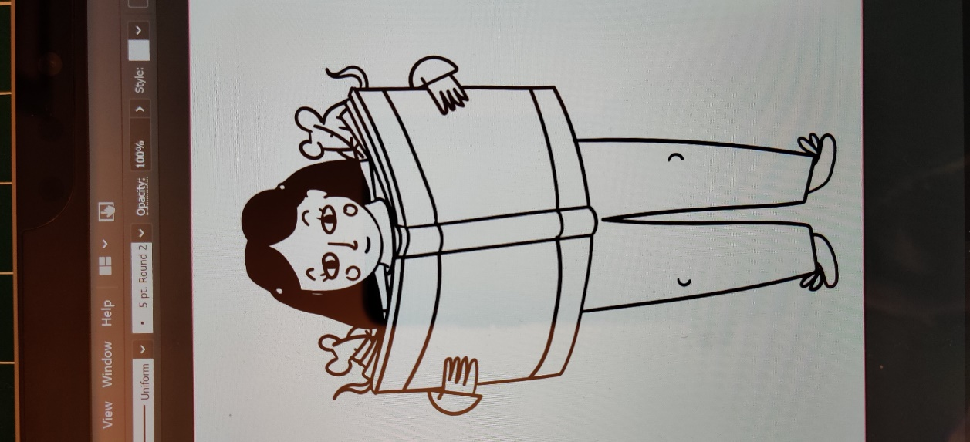
Written by V Croucher
Illustrated by H Rankine
Prologue:
Emma was a mouse. She hadn’t always been a mouse. In fact, up to a few moments ago she had been a school girl. But now she was a mouse. It was an odd situation, and she was taking some time to get used to it. The tail was the weirdest bit. That and having four legs but no arms. Every time she thought about moving she would trip over either one of her extra legs or her long, wiry tail. As for trying to pick anything up? As soon as the change happened she had tried to pick up the magical book but, without hands, and being only a few centimetres tall, this proved impossible.
It was time to face facts. She wasn’t dreaming (not that she could pinch herself to check). So it must be real. Emma slowly replayed the events in her head which had led up to this bizarre switch.


Chapter One
It was a warm, autumn day. The trees and bushes were dripping with fiery red leaves, and apples and blackberries were begging to be collected from fields and gardens. However it may as well have been coldest winter, thought Emma, as she was trapped, stuck in a stuffy classroom. She had spent most of the afternoon staring at the clock, eager for home time, while listening to her teacher droning on. Usually Emma thought that school was great, yet today it just seemed wrong to be stuck indoors when there was so much to do outside, leaves to kick, trees to climb, dens to build, all before it became impossible when the icy winter arrived.
A jab to her elbow rudely bought Emma back from her daydreams, and she turned to give her best friend, sat at her side, an evil look. However, she soon realised
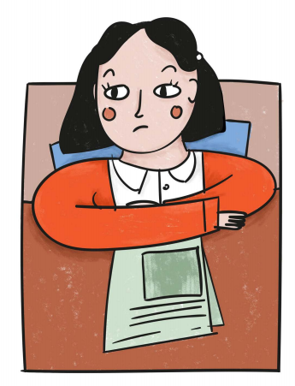
why she had been so urgently bought to reality… her teacher was setting homework for the weekend!
“And so, as I say, your homework is to find information about a famous woman in history. You will then present your findings to the class. You can use props, pictures whatever you want. However, when researching the facts you are not allowed to use the internet!”
At once there was an astonished gasp from every member of the class. No internet? But how on earth were they meant to find anything out? Were they supposed to time travel and ask the person themselves or something? Impossible!
Turning from one to another, each child’s face mirrored the shock they all felt. They had been asked to look things up at the beginning of a term before, like when they did the rainforest topic, but adding this evil catch? What could the reason be?
As if reading their minds, the teacher continued
“Perhaps you think this unfair? Well, maybe I feel it is unfair to me when I am expected to accept a piece of homework which quite obviously has not been created by the child, but was in fact simply cut and pasted from websites. Whilst those children could be applauded for their imagination, this will not help them in their later life. (Ignoring the titters and mumbled giggles erupting all over the class, their Teacher continued) So, I remind each and every one of you that there will be NO USE OF THE INTERNET… AT ALL!”
The stunned silence was only broken when, minutes later, the home time bell spurred the dazed class to life. Each child collected their coats and bags and dashed out of the classroom eager to discuss this bombshell far away from their insane teacher.
Gathering in a corner of the playground, Rose and her friends all chatted at once;
“Did you cheat? Was it you?”
“So where else can we get the information?”
“Are there any famous women?”
This last question rang out loud above the others. The girls trawled through their memories, trying to remember any famous women, yet names like Einstein, Neil Armstrong, Abraham Lincoln and Leonardo da Vinci continually arose, whilst no females came to mind.
“Look’. Said Emma. `There must be some famous women. Think about TV. Who do they talk about on those history shows?”
After a moment or two, the girls each glanced up, nervously saying the name of a woman they had remembered:
“Florence nightingale”
“Queen Elizabeth”
“Mary Seacole”
“Joan of Arc”
“Mother Theresa”

Encouraged by this progress, the girls began to chat animatedly, sharing what they remembered of each woman. Emma, however remained silent. Why couldn’t she think of anyone? There must be someone else. Come on brain… think!
The group of girls soon split up as each left to go home for the weekend. Yet still Emma’s mind was blank. How else could she think of someone? She could use one of the women her friends had named, yet that wouldn’t be fair, stealing their idea. No. She needed to come up with her own person.

When she arrived home she ran straight into the lounge where her Mum was busy on her computer.
“Mum. When you were little, how did you find things out?”
Her mum grinned, “I’m not ancient you know!”
“Sorry, I didn’t mean that but, well…” Emma explained her homework while her mum listened quietly.
“Do you remember what we used to do when you were little?” She asked
“Eh?” responded Emma
“Where did we used to go at least twice a week? You used to go on the back of my bike and sometimes you did a singing group there.”
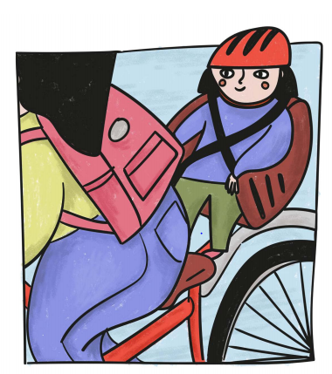
Bewildered, Emma wondered why her mum had answered a question with another question. Was it mad adult day?
Seeing her confused expression, her mum continued.
“The library!”
Of course, she thought. How could she have been so daft? There were loads of books which held information on everything she could possibly want to know about only a short walk away. Looking at the clock she checked whether she could go now.
Having rummaged around in drawers and boxes until they found her library card, Emma set off.

Chapter Two
The library was a large, old building in the middle of town. It was a lifeless, dull grey colour and would have easily blended in with the rest of the shops if it hadn’t been for the pond outside with some enormous metal bird statues in it. Emma had often noticed them but rarely paid attention to the building itself. However today, she slowly climbed the stone stairs leading to the great glass door. Pushing cautiously she walked in.
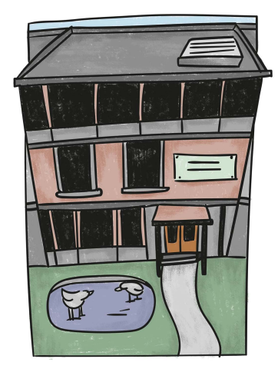
Emma was met by the welcoming smell of books and warmth which instantly caused a sense of calm to soothe her. As the door closed gently behind her she felt something brush hurriedly past her legs. Looking down she saw a very scrawny looking cat dashing from the library. Perhaps it had followed people into the library in search for food but become trapped and, seeing the door opening, quickly escaped into the sunshine.
Emma quickly forgot the scraggly tabby cat, becoming aware instead of the lack of noise: No phones buzzing, no texts beeping, or loud voices speaking into their mobiles. Instead, were the sounds of pages turning and the gentle tap tap of a computer keyboard somewhere nearby.
Racking her brains to remember what to do, Emma wandered around until she found the non-fiction section. She remembered that non-fiction meant `information’ or `fact’ so she knew this would be a
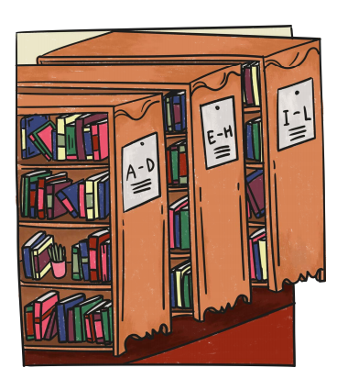
good place to start. Yet once she had arrived she realised it would take hours to go through each book looking for one with a famous woman. Seeing a Librarian, she asked for some help and was shown how to use the library’s computer. Carefully noting the section number she would need, Emma scanned through the spines of the books until she found the famous historical people area. It was huge! She had expected to find one or two books, so was overwhelmed and extremely grateful when she realised there were bookcases full of hundreds of books on the subject. Just as she was considering where to start looking, a slight movement caught her eye.
Emma watched with fascination as a creature scurried quickly towards one of the bookcases in the shadowy part of the section, occasionally making odd jerky movements before continuing on its mission. Leaner closer, she realised that it was a small, greyish brown mouse. It seemed to draw her towards it as if casting a spell, forcing her eyes to follow it as it ran to the darkest part of the area where the bookcases were veiled in shadows. It stopped at a shelf and carefully began to crawl up, up, up until it was almost eye level. Catching her breath Emma wanted to take a step back yet found herself tilting closer as it scuttled in front of a book barely visible beneath a cover of cobwebs and dust. Having seemingly achieved its goal, the mouse sat still watching her watching it. Suddenly, it began squeaking noisily as if shouting at her or warning her. Then, just as quickly as it had appeared, it vanished.
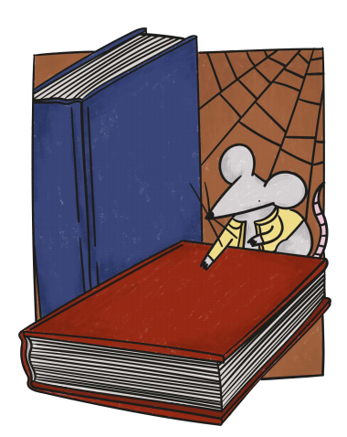
Having searched vainly in the shadows for the mouse, Emma returned to the book the strange mouse had rested by. It was almost hidden, pushed behind others on the shelf. Intrigued, and gently wiping the dust and cobwebs off of the spine, she read the title; Rosa Parks.
Emma vaguely remembered Rosa Parks being mentioned once as a black American lady who helped fight racism a long time ago however, Emma had never felt compelled to find out any more about her as she hadn’t seemed relevant to a British girl. Today though, her Teacher’s instructions ringing in her ears, and her own desperate feelings urging her to explore, she pulled the book from the shelf and opened it. As the pages slowly fell open, a cloud of dust arose, engulfing both Emma, the book and all immediately around it. Coughing and sneezing, she frantically tried to wave away the dust, but the more she waved, the more she felt a wind swirling all around her, blowing the dust deeper into her eyes and lifting her off of the floor. Terror causing her to drop the book, Emma felt herself raised higher into the air until she was level with the top of the bookcase. As she reached her hands up to protect herself from the ceiling which was rushing towards her, she was suddenly suspended in mid-air. Looking around frantically, Emma didn’t have time to form a plan to escape before she was swiftly sucked down faster and faster until nothing was left except for dust and an old book, seemingly carelessly dropped on the floor in a rarely used section of the old library.

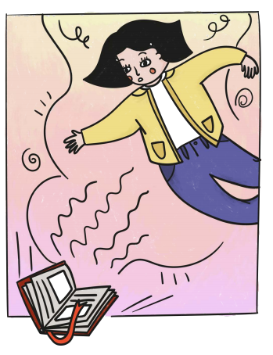

Chapter Three
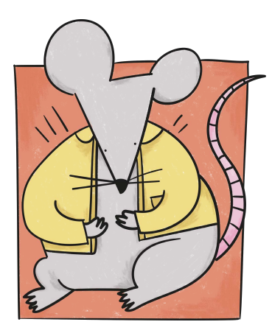
So, now she was a mouse, sat feeling confused, in a dark library. She hadn’t realised that she had changed in any way at first. She just thought that she had fallen down and that was why she was so low on the floor. It wasn’t until she had a really good look at her surroundings; the giant book open on the floor beside her, the cobwebs bigger than carpets, the enormous chair and table legs which seemed to stretch higher and higher into space, that she realised something had gone seriously wacky.
Having determined that she couldn’t pick up the book which had sparked this change, she wondered what else she could do. As Emma sat muttering to herself, occasionally being tickled by what she now realised were her whiskers, she heard a voice.
“Yoohoo. Are you ok? That was a big flying bump you had. I’ve never seen a giant become one of us before!”
“Giant? Eh? Who is speaking? Where are you? Show yourself?” demanded Emma nervously.
“Oh sorry, I should have introduced myself. I’m Maddy.”
With that, out of the shadows came the most enormous mouse that Emma had ever seen. Cowering into a corner she took in the enormous eyes, long, snake like tail and grey-brown fur. Feeling trapped, Emma was beginning to panic when a thought entered her mind. `Was it a giant mouse or was it a normal mouse? If she herself was a mouse then she could expect other mice to be the same size as her right? Grabbing hold of this thought she clumsily took a few steps forward.
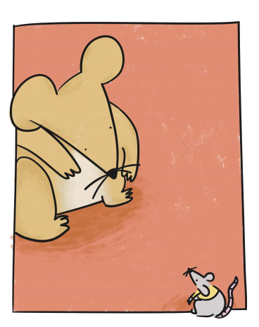
“Um. I’m Emma. Do you know what happened? Can you help me get back to normal please?”
“Aw, shucks, I’m sorry but I’ve never seen anything like this before. I was just out looking for food when I saw it happen. Maybe you would like to come back to my hole and have a bit of rest. You’ve had a big shock.”
While Maddy was talking, Emma had been watching
and listening and had realised that the mouse was talking in an American accent. Things were just getting stranger and stranger. First she becomes a mouse. Then she meets an English speaking (not squeaking) American mouse. On the plus side mice don’t have to do presentations or homework so…
Disrupted from her thoughts, she realised that Maddy was awaiting an answer.
“Yes please.” She quickly replied, and, awkwardly telling her many legs what to do, she set off to follow her.
Emma breathlessly scurried behind Maddy as they leapt from shadow to shadow, carefully avoiding any areas where people were sat. Despite her loud gasps for breath, Emma noticed a change in the hum of the library. Whereas before the quiet had been a mixture of page turning and tapping, now the tapping was replaced by a scratchy scribbling noise. Frustrated that she couldn’t see up onto the tables to find out why the computer taps had gone, she dismissed the thought and hurled her new body through holes and over dropped objects until they came into the daylight.
The outside, now she was a mouse, was far scarier than it had been as a girl. Everything seemed so much bigger and faster and louder. People’s enormous feet pounded the paths skimming her tail and whiskers, the loud thuds ringing in her sensitive rodent ears. Pavements which as a human girl, had barely made her step up, were now massive mountains for her to scale and the strange cars which growled past seemed like gigantic spaceships or tanks.
When she had entered the library it had been a warm autumn day, yet now it was cloudy and Emma felt much cooler than she had in the library, especially now she no longer had any clothes on! The rest of the journey to Maddy’s home was a blur expect for the realisation that things were very different here and there were Christmas decorations scattered along the route. Something else didn’t seem right, yet she couldn’t quite put her finger on it, and the thought lay forgotten in her efforts to make her mouse body behave.
Maddy’s house was in a block of apartments. While Emma rested, catching her breath, Maddy had explained that her family had lived there since the building had been built, hiding in their hole and finding food nearby. She also mentioned that she shared it with some friendly `giants’. Maddy seemed particularly fond of a woman called Mineola and happily told her how this woman left treats for Maddy and her family, and never screamed when she saw her.
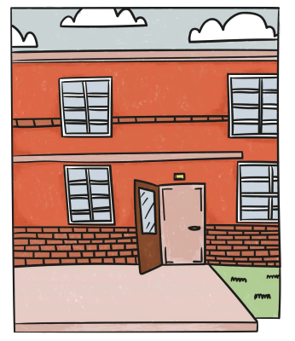
While it had been nice to learn about Maddy’s life, Emma felt that she must try and focus on finding a way back to her body.
“Mineola works in a big factory which makes stuff for the giants to wear because they don’t have any fur of their own. Maybe we could make find you a new giant body there?” suggested Maddy.
No fur? Stuff to wear? Emma realised that Maddy was talking about a clothes factory. Well, she didn’t have any other ideas so perhaps it was worth a try.
“Ok. How do we find it?”
“She and another lady from the apartment catch the bus there every day. I followed them once in case there was any food but unfortunately not. I bet I could get us there by remembering all of the smells.” Replied Maddy proudly.
Heading off, the two mice darted through roads and alleys, past shops and restaurants, occasionally stopping for a sniff before bounding on. During one of these breaks, Emma had the chance to have a good look around. That strange uneasy feeling hit her again. What was it that just wasn’t right? The cars were weird and on the wrong side of the road, the clothes people were wearing looked odd… but there was something else….
Just as she felt she was about to work it out she noticed Maddy dash off in between two water fountains. All of a sudden the realisation hit Emma causing her to stop in shock. It was the signs and the fact that there were two of lots of things: two water fountains, two schools virtually next to each other, two churches, two waiting rooms and school buses full of only white children while children of other colours journeyed on foot. It was however the signs which had really shocked Emma. Signs read `coloureds only’ or `whites only’.
WAITING ROOM
FOR COLOUREDS ONLY
By order of the Police Department

Drinking Fountain

White Coloured

Up until that moment she had held onto the hope that it was just a dream that she could wake up in her normal body having fallen asleep in the library. Yet all she had seen and heard in the last few hours however told her something far scarier, far more momentous had happened. She had travelled back in time to a different place and a different body and she didn’t have a clue how to get back!

Chapter Four
When Emma had eventually been able to shake herself from her terrified stupor, she had continued the journey to the factory. On her way she had glimpsed a newspaper dated December 1st 1955. No wonder the clothes, hair and cars were all odd looking!
Once the mice had arrived at the factory they had searched for hours for Mineola but when they heard the machines being shut off they knew they must give up. Emma, feeling anxious and disappointed turned to her new friend:
“Now what shall we do? I want to go home. I want to be in my own body. I don’t want to stay here in this horrible world where black and white people are kept separate, and where I am a tiny mouse!”
“Hush now, let’s go home and have something to eat and try to come up with a new plan. Look, there’s Mineola’s friend Rosa packing her bag ready to catch the bus. Come on.”
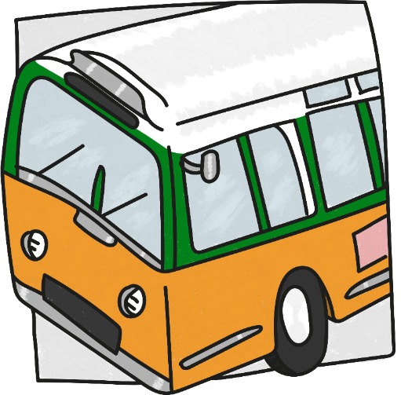
Feeling weary, Emma turned her head to where Maddy was pointing with her front paw. A short lady wearing a smart brown jacket, neat hair parted in the middle, and thin glasses was coming towards them. She was wearing a small flower clip in her hair and holding a large handbag. She couldn’t have been very old, maybe 40, but the way she walked made her look older; a slow, tired walk.
Carefully copying Maddy’s every movements, Emma slipped unnoticed into the handbag. Being bumped along in a dark, cramped bag was at least warm. As she stretched her legs, one by one, marvelling again at her extra limbs, Emma heard the unmistakable noise of bus doors opening, and felt Rosa climb aboard. She was confused then when she felt her get off of the bus, walk a bit and then get back on again. What was happening? Had she changed her mind? Cautiously poking her head out of the small hole in the side of the bag where the stitches had come loose, Emma noted that only white people were allowed to walk to their seats from the front of the bus.
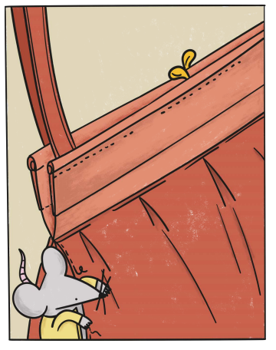
Black people were each paying then getting off, only to sit at the back via the back door.
Ignoring Maddy’s excited whispers telling her that Mineola was on the bus too, Emma continued trying to get her head around this strange set of events. She watched as the same thing happened at the next two stops. Each time after paying at the front, the person would then walk from the front or go to the back door to find a seat at the back. By the time the bus pulled up to the third stop, every seat on the bus was full, yet three more people were getting on.
Watching the first two people pay and wander up and down the bus, front to back searching for a seat, Emma nearly missed the third person who, having paid, stood waiting. Figuring that the driver would pull away expecting the three left standing to simply hold on, it was with some surprise that she heard him pull on the handbrake and stomp up the aisle. He grabbed hold of a sign which had been balanced over the back of the seat in front of them and slammed it down on the back of Rosa’s chair. Emma only had a brief glance, but saw that it said `coloured section’. Now he stood menacingly over Rosa and two other black people.
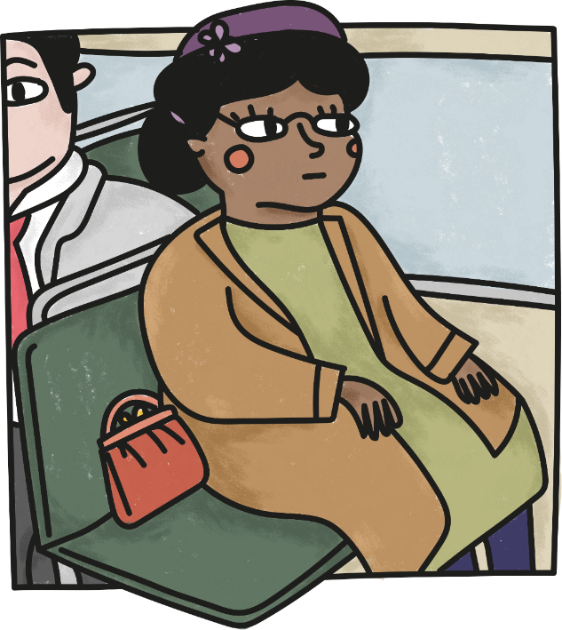
“Move” he demanded glaring angrily.
The two people nearby swiftly left their seats so that the white travellers could have the spaces instead, yet Rosa didn’t move. She simply continued to sit as if she hadn’t heard his rude request.
“If you don’t stand up, I’m going to call the police and have you arrested,” he shouted at her getting more and more cross.
“You may do that,” Rosa calmly replied and, as if totally at ease, turned coolly to look out of the window.
In a rage, the bus driver thundered back down the aisle and out of the bus doors. Emma watched him as he went to a phone box and made a call. She couldn’t hear what he was saying, but by the irritated look on his face, and the hushed, fearful whispers from behind her, she knew it wasn’t good. Why wasn’t Rosa getting up? Emma knew that what she had been asked was unfair but was it worth getting in trouble with the police? This question was shoved out of place immediately by a second, stronger thought: Why would the police be angry? The driver had been the one to shout, to cheekily move the sign, to demand she move even though she had been sat there first. No, it was him that was going to be in trouble, not Rosa. Beginning to feel reassured, Emma settled back into the bag to wait. Maddy had found a biscuit crumb and seemed completely unaware of what was happening on the bus, yet Emma listened carefully to every sound until she heard the heavy thump of the bus driver returning, only this time with two other pairs of feet following closely behind. `Aha’ she mused, perhaps he was being made to apologise for being rude? Waiting gleefully for the apology, she was astounded when she saw one of the policemen stop in front of Rosa and ask;
“Why don’t you stand up?” His tone of voice showed that while obviously confused by Rosa’s refusal to move, he didn’t seem to be the least bit surprised or angry at the driver who had caused the fuss in the first place.
Head swirling at this odd reaction, she heard Rosa reply:
“Why do you push us around?”
Now what was going on? What had she meant? Emma was getting more confused by the second. No one was acting as she would have expected. The driver was rude to the black people but didn’t get in trouble, the police were expecting Rosa to quietly give up her seat and now Rosa was answering in questions!
“I do not know,” he replied sounding taken aback, “but the law is the law and you are under arrest”. With that, he grabbed her hands, shoving them behind her back and handcuffed her as if she was a thief.
Ducking down, Emma only just managed to stay in the bag as it was swung in the air and thrown into a police car and whisked off to city jail with Rosa and the police men.

Chapter Five
During the journey in the police car, Emma had quizzed Maddy on why people were being so odd. She was told that Montgomery, where she had appeared, as one of the Southern States of America, operated under the ‘Jim Crow laws’. These had been created not long before Maddy’s home had been built and were meant to give African Americans “separate but equal” status and treatment. Emma was appalled. Rather than making people equal, it just served as a way to make sure black and white people led very separate lives, and that black people were treated the complete opposite to equally! Emma’s mind struggled with this idea. She had been bought up to be grateful that her world was so multicultural as it meant a variety of food, festivals and friends, plus, as her mum was forever saying, who would want a world full of just one type of person? It would be so boring!
Before long Emma felt the bag being bumped heavily onto a desk at the Police station. Curious to discover what would happen, she once again tip toed on wobbly paws to get a better look. Rosa, still handcuffed, was being forced to have her fingerprints and photo taken, yet all of the while she kept silent and calm. Listening to the conversation amongst the Police, Emma learned that the men who had arrested her were called Officers Day and Mixon. When the time came for her to be questioned, Day and Mixon left her, and Rosa and the bag went into a dark, dingy, grey room, which smelt of smoke and old coffee. A different policeman was with them now, and he was sat opposite Rosa, behind a large, steel table.
“Right then Rosa, would you like to explain to me why you so deliberately broke the law? Don’t tell me you were tired as that’s no excuse!”
“I did not break the law. Laws are sensible, and are there to protect us. This was not. It was the law which was wrong, not me”, Rosa replied barely whispering yet her voice coming out strong and clear. “I was not tired physically, or no more tired than I usually was at the end of a working day. No, the only tired I was, was tired of giving in. I am tired of being treated unfairly just because of the colour of my skin. I did not want to be forced off of a seat that I had paid for. I did not plan to get arrested, goodness knows that I have plenty to do without being in jail. But when that man shouted that I had to move, well, I didn’t hesitate to protect my rights. We black people have had to put up with unfair laws for too long. The more we give in, the more we allow ourselves to be treated unfairly. I am tired of it all!”
“So you admit that you ignored the law because you were tired!” the Policeman claimed loudly, as if wanting others to hear.
“No. That is not what I said. I said I am tired of being treated unfairly and I stayed sat down in protest. I am determined that this will be the last time I suffer humiliation of this kind.”
Her response was met by silence.
The next few hours passed by in a blur of questions, being shuffled in and out of rooms; Rosa always answering with the calm strength that she had shown so far. At one point, a smartly dressed man had entered her cell where she had been waiting for the next barrage of questions. He had shown her a piece of paper and told her that it was a police report stating that had been charged with "refusing to obey the orders
of the bus driver."
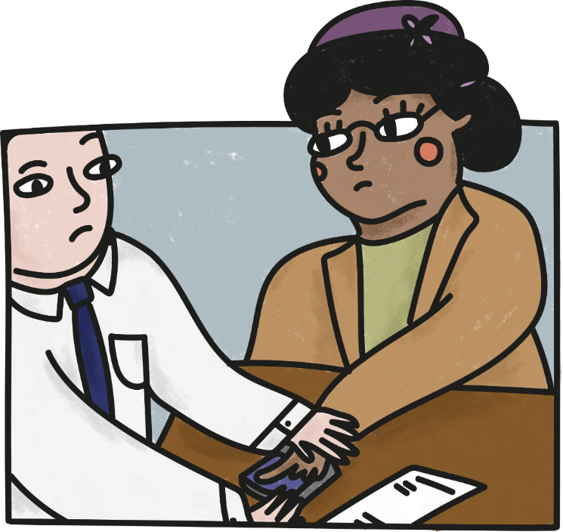
`Huh. Orders which were rudely shouted and totally unfair! I don’t think I could stay that calm’, mused Emma to herself. She thought back to times when she had felt wronged and had shouted, stamped her foot and moaned. She felt incredible pride in being with this woman who was standing up for her rights even though everyone was against her. Emma had only been in this time for a short period, yet she had seen such unfairness because of colour and knew that Rosa was right to do what she had done.
Maddy, who had fallen asleep after her snack, now woke up and, after a few moments shuffling, she called to Emma.
“Emma, look, I think we can get out”. She was pointing over to a hole in the police station floor, too small for people to notice, but just big enough for a mouse to escape through.
“But what about Rosa? We can’t just leave her here.” Emma replied anxiously.
“Think about it. How are two tiny mice going to help a woman in jail for standing up for her rights? It’s more likely that they will find us and …” Maddy shuddered, unable to finish her sentence, so overcome with fear at the possibilities of capture.
Realising that Maddy was right, but reluctant to leave this courageous lady, Emma silently followed Maddy out of the bag, through the hole, and into the night outside.

Chapter Six
The mice had only just left the building when Emma heard the most ear piercing sound she had ever heard. Immediately she realised that it had come from Maddy. Standing still Emma followed Maddy’s gaze and, to her horror, saw the most enormous pair of green eyes staring out of the dark. Time seemed to stand still as her own tiny eyes began to focus on the massive tabby cat sat, tail twitching, watching them. Emma recognised its pose. It was getting ready to strike, to pounce on it’s prey; only this time the prey was them! 