**Pippa and the new school**

(book 1 of series)

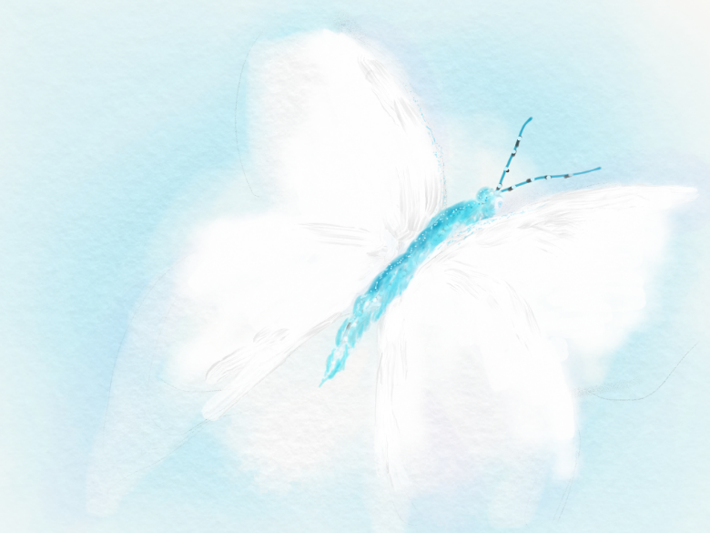

*Written by V Croucher*

*Illustrated by S Young*

**Prologue**

Pippa had the best Godmother in the world. That wasn’t bragging. It was a simple truth. Aunty Cate not only did the usual Godmother’y things like giving presents and doing the odd bit of babysitting, but she also took Pippa on amazing adventures, like the time she was supposed to be hanging around her Mum’s super dull work during the holidays.

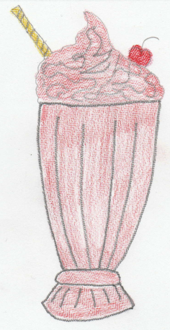

Pippa had been all set for a day of being totally bored when Cate turned up and whisked her away to a café in the middle of nowhere which served the most amazing strawberry milkshakes (with cream, ice cream and sprinkles)! Another time, Aunty Cate took her to a nail bar in the shopping mall and they got their nails painted and even had little glittery sparkles stuck all over them!

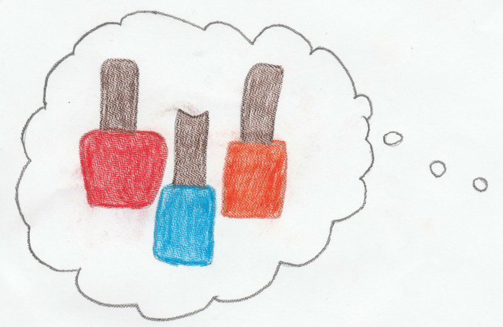

The thing with Cate was that she never did what you expected her to do. That was what made her so special, that and her mischievous smile. So, when Aunty Cate died Pippa felt that she would never have another adventure again. She felt sure that life was doomed to be boring, and… expected.

Boy was she wrong!

**Chapter One**

A lot had happened to Pippa over the last few months. Not only had she lost her treasured Godmother, but her family had moved house and so the park, canal and friends that she knew and loved so well, were now gone. They hadn’t moved hundreds of miles away, but for Pippa, it may as well have been. What use was a train to a school girl? It wasn’t as though she could fly to the local station, hop on a train and pop to her old park to see friends was it? As a result of this Pippa found herself feeling lonely and rather nervous as August turned to September and the time came that she would need to start at her new school.

Pippa woke up early the first Monday in September with a strange swirly whirly feeling inside of her.

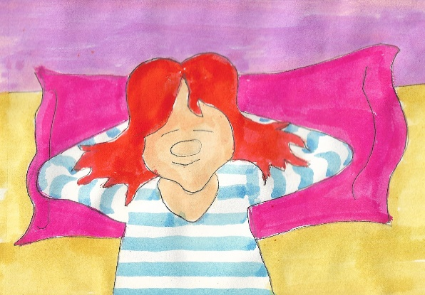

Was she poorly? She felt her head, then pushed gently on her tummy. Nope, she seemed ok. So what was it that was making her feel so odd and fluttery? All of a sudden she sat up and swung her legs over the side of her bed as she remembered: she was starting at her new school today!

Pippa’s Mum and Dad had tried to be cheerful about it. They had taken her for a drive to show her the school, and she had even been in to visit but… She didn’t want to change schools. She didn’t mind moving house because it meant she got to have an enormous room, but what was the point of a big room when you had no friends to play with in it? Yet here she was, on a Monday morning waking up in a strange house and having to go to a new school.

As Pippa put on her unfamiliar bogey green uniform, she began to worry:

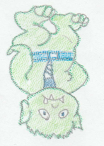*What if she had a mean ogre for a Teacher?*

*What if she couldn’t find the toilets?*

*What if they had gross things like slimy slugs and toasted turnips for their school dinners?*

However, all of these concerns were nothing compared to her biggest, most terrifying, gigantic, monster of a fear… what if no one liked her? Pippa felt she could cope with anything as long as people were kind to her.

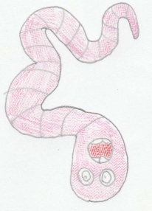

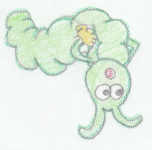During the next hour she brushed her teeth (whilst the concern caterpillars curled and quivered inside her) she combed her hair, (and the worry worms wobbled and wriggled in her tummy) then finally, she put on her shoes, carefully tying the laces - a skill she had only mastered this year with Aunty Cate’s patience and little `tricks’ to help her remember how to do it, and was rather proud of this – until she could delay no longer. It was time for school!

Pippa’s new school was hidden away amongst a maze of houses just outside of town. It had lots of yellow bricks and square windows, and was so wide and flat that it looked like a giant had stamped on it in a rage. As Pippa nervously crept towards it, being pulled reluctantly by her Mum, she noticed other things too. As she passed the car park she spotted a shadowy space leading into a gloomy forest. She also glimpsed a large bin; like the type you see in nightmares which the young child is thrown in by the school bully. Pippa began to shake.

Having given her Mum one last tearful kiss goodbye, and had her fingers unwound from her neck, Pippa stood tall, shoulders back and prepared to meet her doom (or new class… they seemed the same right at that moment). The lady from the office chatted to her as they walked towards the room, but Pippa was concentrating so hard on not crying that she didn’t hear a word and within what seemed like a few seconds, she was stood in front of the room which would be her new classroom.

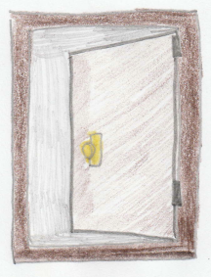

With the constant fear of no one liking her gnawing away and causing her to be quieter than usual, the day passed by in a blur of faces and names, none of which she could remember. Playtime was just as bad as she had imagined; she waited until everyone else had got their coats and run out, before she slowly followed behind, reluctant to be noticed. Once she was outside she could see all of the children from her class happily laughing, running and playing. Not playing with her. Feeling dejected and alone she walked silently to a bench. While she 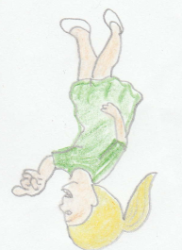sat, she spotted a few girls looking at her and giggling.

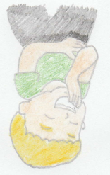

“They are probably making fun of me, she thought, because I’m the new girl”. Determined not to let them get to her, she just looked at the floor and pretended not to have noticed.

Lunchtime wasn’t any better as she didn’t know where to go and had delayed following the others for so long that all of the spaces at the table for her class were full so she had to sit alone somewhere else. All in all it had been a thoroughly miserable day and Pippa was overjoyed when the bell finally rang at the end of the day and she could rush into her Mum’s warm, comforting arms.

Sobbing in the car on the way home, Pippa wanted to share her day with her Mum, but knew she would never understand, and may even be cross at her for not trying hard enough or something weird and `adult’y’ like that. As soon as she got home she rushed out into the garden to grab her guinea pig `Magic’ who, she felt, was her only friend left.

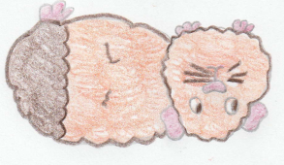“What am I going to do Magic? She wept. Why don’t they like me? Why do I have to go to a new school? Why can’t we just go back to our proper home?”

Shoulders heaving, she let herself cry until she felt that she no longer had any water left in her whole body. Sniffing, and wiping her nose, she whispered

“I wish aunty Cate were here. She would have been able to persuade Mummy to move back home or at the very least she would have known what to do to make this less terrifying.” As the words left her mouth, Pippa felt something brushing against her cheek and, turning, saw the most beautiful, stunningly white butterfly she had ever seen. It swept past her and then flew gently away, occasionally circling back as if to encourage Pippa to follow, before continuing on its path towards the house.



Intrigued, Pippa put Magic back in her run and tiptoed behind the butterfly. Desperately trying not to scare it or hurt it in any way, Pippa followed it through the back door, up the stairs and into her bedroom where it eventually stopped on her rocking horse. It then just sat there, in a patch of sunshine coming in through the windows, as if resting.

Pippa sat quietly, just watching the butterfly for a few minutes, until she found her mind wandering off back to the day that she had been given the horse. It had been her 3rd birthday and she had been going through a horse phase.

**Chapter Two**

*Pippa had asked for a pet horse for her birthday and felt very disappointed when none arrived. However, later that day, an enormous present, wrapped in shiny paper and covered in bows appeared in the lounge.*

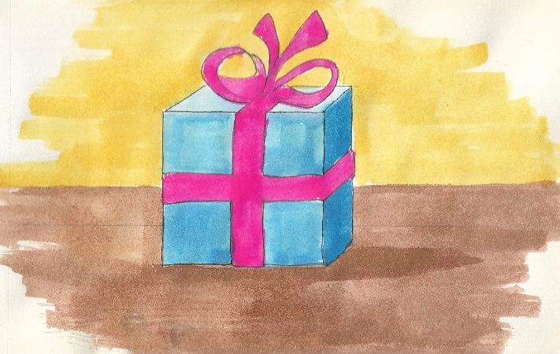

*Pippa was in the middle of her birthday party and hadn’t seen anyone bring it in. This seemed strange, but perhaps it had been while she was playing `Pin the tail on the donkey’ or something? Shrugging off her questions she gingerly walked over to it. In an instant Aunty Cate appeared at her side, as if from nowhere.*

*“Hey there birthday girl. Are you having a lovely day?” she asked, giving that impish grin which only she could do.*

*“Yeeees, Pippa had replied hesitantly, but I didn’t get my horse.”*

*“Hmmmm, are you sure?” Aunty Cate asked in a mysterious manner.*

*Now, the present was at least as big as Pippa (at the time) but there was no way it could be a horse, plus, it wasn’t moving. So what could she have meant? Pippa rushed outside to check that there weren’t any horses in the garden, but upon spotting only the usual cars parked along the road, gloomily returned, dragging her feet back to the lounge.*

*“Don’t worry, the day is not over yet, maybe there will be something even better than a pet horse for you in here?” Aunty Cate tempted, pointing to the large gift.*

*Knowing better than to question her Godmother and her unusual ways, Pippa began to pull off the paper, and could not believe what she found. Not only was it a horse, but it was a rocking horse! She wouldn’t have to feed it or clean out it’s stable (which she had secretly been a bit worried about, being only 3 after all). It turned out that Aunty Cate had made it herself, right down to the tail and bows.*

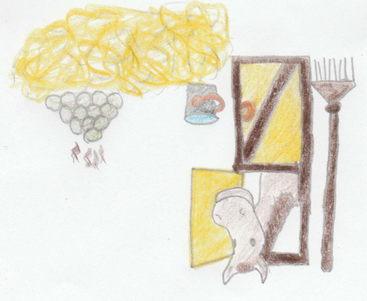

Tearing herself back to the present time, Pippa stared intently at the butterfly. Why it was here and why had it landed on her horse?

Pippa had been sat for quite a while and was starting to feel pins and needles in her legs when she became aware of a distant sound. As she moved towards the window to see what it was, the butterfly whooshed up and landed, first briefly on the stirrups and then on the horse’s head. It felt to Pippa as if it was showing her what to do. As if it wanted her to get on. Feeling drawn somehow, she stumbled over to the horse and carefully, not wanting to hurt the butterfly, got on.

The moment she sat down, Pippa felt herself rising, as if lifted by unseen hands. Grabbing hold of the horse’s neck and shoving her feet deep into the stirrups to stop herself falling off, she looked around wildly. There was no one there, yet the feeling of rising was now accompanied by a strange bumpy feeling, as if… as if she were riding on a horse faster and faster, wind howling in her ears until it became almost unbearable.

This sense of movement, along with the fear of letting go of the horse were the last things she remembered before everything went black.

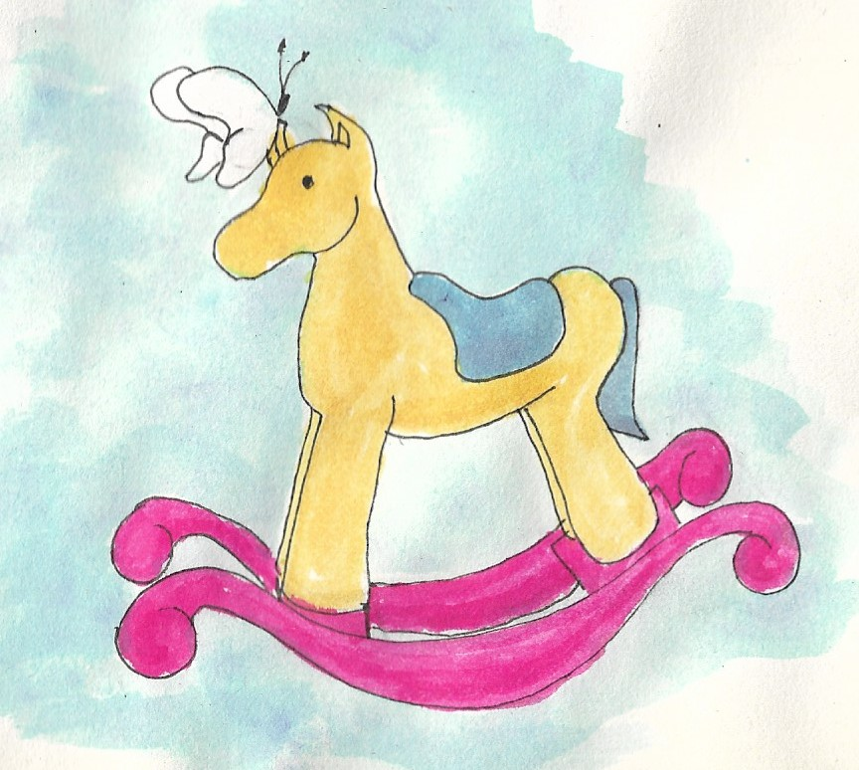

**Chapter Three**

The first thing Pippa was aware of was that she was no longer moving. Slowly and hesitantly opening one eye, then the other, she looked around her and was astonished to find that everything was in black and white! Just like it looked on TV in the olden days. The grass on the field, trees swaying gently in the breeze, bricks on the large building in front of her, and even the birds overhead were all shades of black and white. It was as if a mighty vacuum cleaner had sucked the colour out of everything, leaving only the shadows and lights of an old fashioned movie.

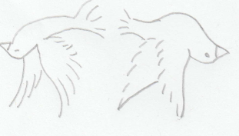

Tentatively releasing her grip on the horse, but being wary about actually letting go (after all, what was to say she wouldn’t find herself spinning and galloping helplessly again, and if she did she was determined that she would be ***on*** the horse, not dragged **behind** it!) she tried to relax her hands and take in her surroundings. She seemed to be outside of a school as there were loads of children everywhere in very smart uniforms and straw hats playing with yo yos, marbles, skipping ropes or with strange hoops at their ankles which they twirled around and jumped over. Where was the playing-card swapping, standing in groups talking about computer games or comparing smart watches which she usually saw in a playground?

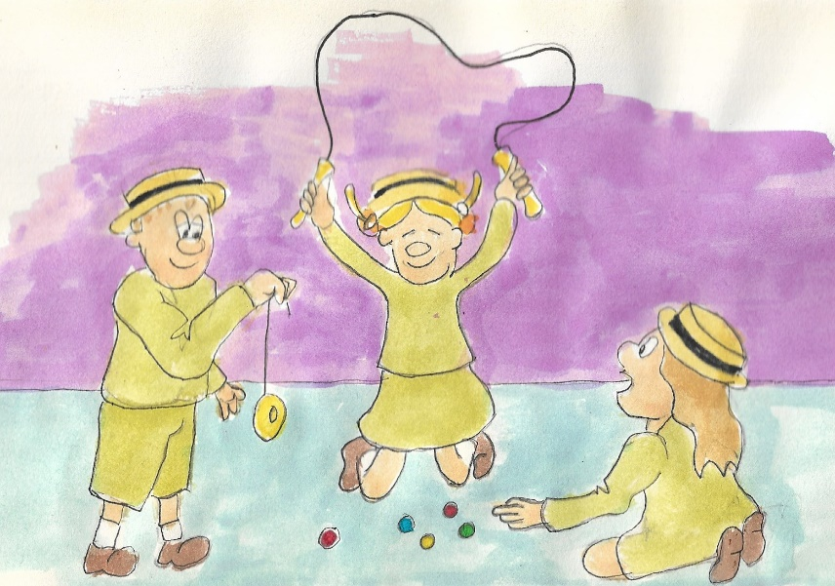

Taking in all of the busy excitement around her, Pippa found her eyes being drawn to a familiar looking girl sat by herself on a strange looking roundabout. Where did she know her from? Anxious not to look as if she was staring, Pippa cast quick glances at the girl.

Hmm, the hair, maybe if it were a bit shorter and if those ugly glasses were swapped for prettier ones could it be…? But those eyes… there was something missing… oh yes, she would know those eyes anywhere, although Pippa only knew them as constantly surrounded by blue eye shadow. It was her mum, only much younger, in fact, similar to Pippa’s age now. Yet how could this be possible? One minute she was in her room looking at a butterfly feeling sad and alone, and the next she is whisked, galloping and spinning to a black and white world where her mum is young?!

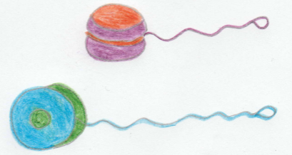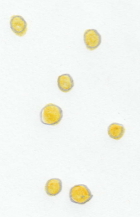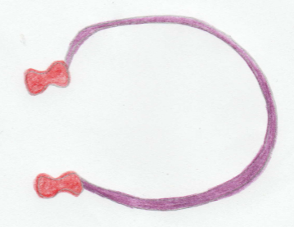Struggling to understand, Pippa felt the horse moving forwards. Tightening her grip, Pippa braced herself for whatever was about to happen.

**Chapter Four**

Pippa found herself moving across the playground, yet no one seemed to be surprised by a rocking horse appearing and pushing its way through the children, dodging balls, ropes and the occasional yo yo. This in itself would have been strange enough but when a child ran full force at them Pippa began to scream and pull wildly at the horse’s reins. Deaf to her cries the horse continued its path until the child was ten metres, five metres, four, three, two, one… Pippa screwed her eyes tightly shut and braced for the thud of collision.

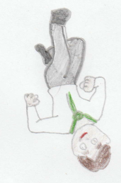

Heart pounding wildly in her chest and rushing past her ears Pippa waited. And waited. Yet still no bang. No thud. No almighty crushing in her side followed by the inevitable falling off of the horse. What had happened? Had the child changed direction? Had the horse moved at the last minute? Hesitantly opening an eye Pippa was shocked to see that the child was now on the other side of them happily zooming around and completely ignorant of the accident which could so easily have happened.

“How odd.” She thought. It was as if he had just run through them rather than (as she presumed) having had to stop and go around.

Calming down after her close call, Pippa’s eyes searched for the Mum-girl in the crowded playground. Pippa knew she had been quite popular at school and was thus surprised to see she was still sat alone. Curious but aware that she could hardly go and introduce herself as her daughter, Pippa climbed down from the horse and walked the last few paces to the roundabout.

“Can I come on?” She asked

Pippa’s Mum-child didn’t move. She just carried on clinging tightly to the metal bars with her hands, and curling her legs tightly into the wooden seat.

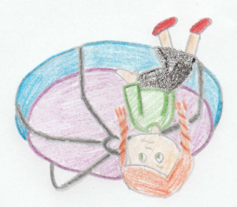

Perhaps she hadn’t heard her? Pippa tried again.

“Can I come and sit here too please? Would that be ok?” she repeated gently.

The Mum child’s eyes briefly flickered and widened, like a scared animal, then just as quickly she looked down, hunched her shoulders and shrugged.

What was wrong? Maybe she had hurt herself or had an argument with her friends. Determined to find out, Pippa softly asked

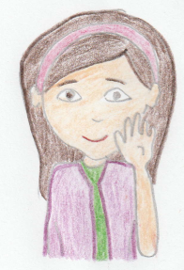“What’s the matter? Why are you sat here by yourself?”

“Oh, said Mum-child. Oh, you ***are*** talking to me? Um, well, um, errr….” She seemed unsure of what to say or do.

“Perhaps if I tell you my name? I am Pippa, what do people call you?” (she knew after all that she couldn’t call her `Mum-child’ now could she?!).

“Why do you want to know?” she mumbled in reply.

“You were alone so I wondered if maybe you wanted someone to chat with. I can leave you alone if you would prefer?” asked Pippa, feeling unsure of how to continue.

Mum-child gazed, quizzically at her before finally saying

“My Name is Elizabeth but my friends in my old school used to call me Bethy. I thought you might be another of those people who stare and laugh at me because I’m the new girl. It’s my first day here you see.”

Shocked, Pippa swiftly reassured her that this was not the case. “Are you sure they are laughing at *you*? Why would they do that?” thought Pippa out loud.

“Well they must be mustn’t they? Muttered Bethy, with a hint of anger in her voice. I’m new and they aren’t. They all know each other and where the toilets are and what to do when the whistle blows, but me? I keep getting it all wrong. Of course they are laughing at me!”

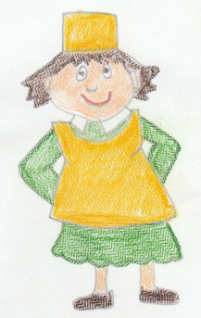

Pippa thought hard to all of the things she had been told when she started at her old school, and how easily she had fit in because they were all starting at the same time. Had this been the only reason? Forcing her mind back to those first few days Pippa thought about how the teacher had helped her find people who liked to play with the same toys as her, the dinner ladies had helped by giving her a lunchtime buddy to play with. Suddenly, she gasped as she realised that she had made friends so easily that time because *she had been willing to try, and to listen to people’s advice.* Perhaps she could help Bethy in the same way?

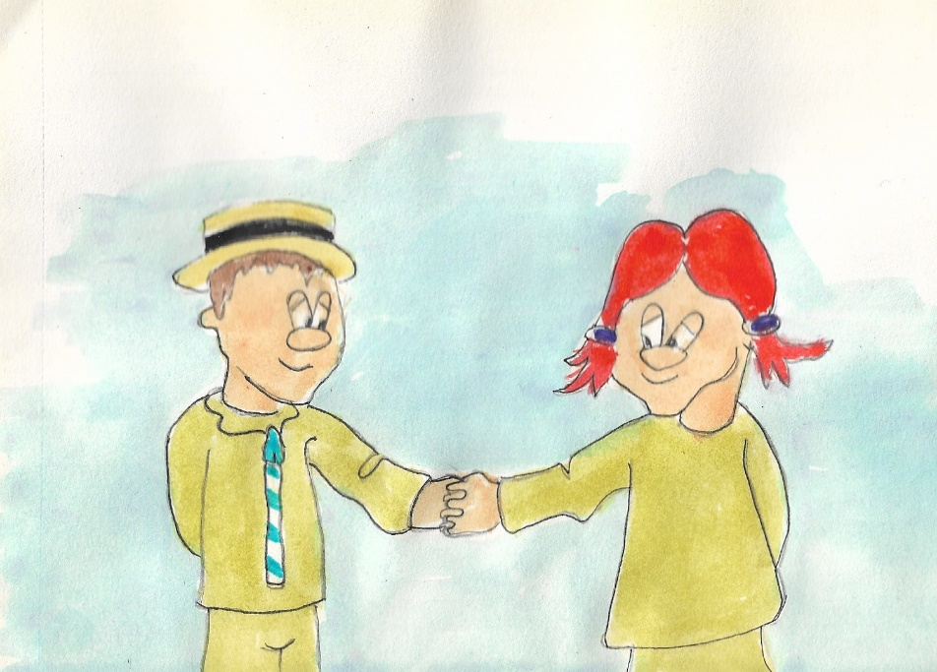

“When I started at school I worried that no one would like me but then I grabbed hold of myself and gave it a try. I said `hello’ to people, and asked to play with them. It wasn’t easy. In fact it was really hard and I had to be incredibly brave but I am so glad I did it. I had the most brilliant friends there and we had such adventures! Wouldn’t you like that too?”

“I hadn’t thought of it like that. I suppose I had been so busy worrying about not having any friends that I forgot to try’. Standing tall Bethy turned and looked at a group of girls that she had been watching earlier. `I’m going to give it a go. Will you come with me?”

Eager to encourage Bethy, Pippa agreed and, holding hands, they made their way nervously over to the girls. As they approached one turned and, seeing them, nudged her friend. Pippa felt Bethy’s hand squeeze in terror but she gave her a comforting look and kept gently pulling her forward.

“Hi there. You’re the new girl aren’t you? You’re in our class. I’m Kim and this is Cate. We thought maybe you didn’t like us because every time we looked at you to ask you to play you ignored us or walked away.”

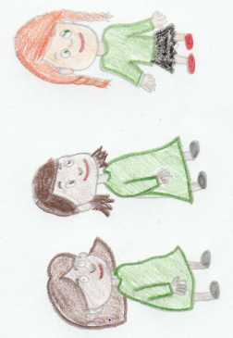

Shocked, Bethy told them how she had wanted to speak to them but been too nervous. As the 3 girls laughed together about their misunderstanding Pippa stepped forward to introduce herself but just as she opened her mouth to speak the girls walked right through her, pulling Bethy along. As they left Pippa could hear Bethy muttering to herself

“I wonder where Pippa went?”

“I’m here!” She shouted waving but no matter how much she shouted, waved and jumped it seemed that Bethy could no longer see her.

Standing confused, Pippa spotted the butterfly. Again it seemed to be beckoning her to follow it and again it landed on the horse.

Realising that there was no more she could do here now that no one could see her, Pippa climbed onto the horse and held on tight. Within seconds she found herself spinning and galloping, wind rushing past until all at once… black.