



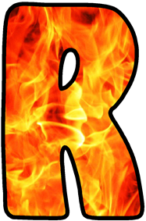



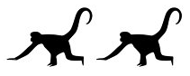


Chapter One: Change
Darkness was all around threatening to suffocate him. Shadows lurked in corners, stretching and retreating in the waning light. Leaping out, only to creep back to its hiding place as the light from the lantern scared it away. Everywhere he turned his eyes were assaulted by red crosses splattered hurriedly onto doors… doors and windows which were firmly nailed shut. He walked down the narrow, silent, foul-smelling cobbled streets of the deserted city, carefully avoiding the muck and waste overflowing from the gutters and feeling entombed by the closely built overhanging houses. The dry, east wind breathed down his neck, bringing the sound of the death cart rattling ever nearer, its’ bell ringing sadly...
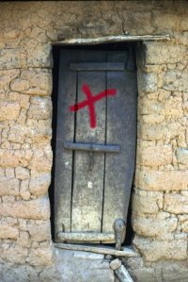
Robin woke with a jolt, covered in sweat, heart pounding. The last major outbreak of Plague had been in April and now it was nearly September, yet the fear and dread never left him. Robin had been lucky as he and his family had survived; by avoiding other people and keeping constant bonfires burning to ward off disease and clean the air. His Father had even taken to the disgusting habit of chewing tobacco in order to be rid of the evil smells which were thought to pass the disease from one person to another.

Shaking off his dream Robin shivered as he got up off of his mattress by the fire. He could hear the hustle and bustle of the nearby lanes and streets which overlooked the wharf. After almost a year of terrifying, deathly silence the sound was comforting to him. He swiftly put on his short jacket and wide shorts, and pulled on the square-toed shoes he had inherited from his brother the year before. He wished he could have something with ribbons, or even a fine square lace collar, but he knew that his Father was busy enough without having to worry about whether Robin was fashionable or not!
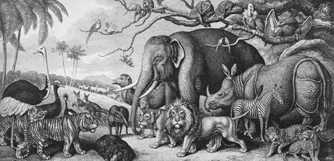
As Keeper in charge of the Royal Menagerie at the Tower of London his Father was constantly feeding, cleaning and generally caring for the animals. As such, he had been granted a home in the heart of the castle, surrounded by its magnificent towers. Robin’s happiest days were when he was allowed to help his Father look after the strange beasts such as elephants, tigers, kangaroos, bears and ostriches which were kept for the King and courtiers amusement. Robin particularly loved watching visitors as they stood on the viewing platforms and stared in disbelief, excitement - and sometimes even fear - as they set eyes for the very first time on these exotic creatures. They may have feared the animals, but to Robin these were his friends; Evie the elephant with her strong trunk was particularly special to him and they had many wonderful times splashing around getting equally soaked during her weekly wash and scrub down. Plus she helped his father moving heavy items within the Tower.
Robin felt himself to be the luckiest boy alive as living in the castle and working with the animals also meant that he had met both the new King and his brother the Duke of York, and it was because of his Father’s friendship with the animal loving royals that Robin was to meet and be apprentice to one of the most important men of the Navy; Samuel Pepys.
As one of 5 children, Robin had always made sure he was at the centre of any excitement. From the moment he first learned to shoot a bow and arrow on Tower Green, pretending the ravens were evil dragons and he the brave knight, he was on an adventure of some kind or other. However, despite his adventurous spirit he was aware that he didn’t do as well at his school work as his Father would have hoped. It was for this reason that he was so nervous about meeting his new master `Mr Samuel Pepys’, as Pepys had a reputation for being a very learn’ed man. Robin had been offered the enviable role as his apprentice and he knew that he could learn so much from him, yet if Pepys thought him not clever enough and sent him back to his Father… Robin trembled at the thought of the disgrace and dishonour which would follow.
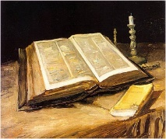
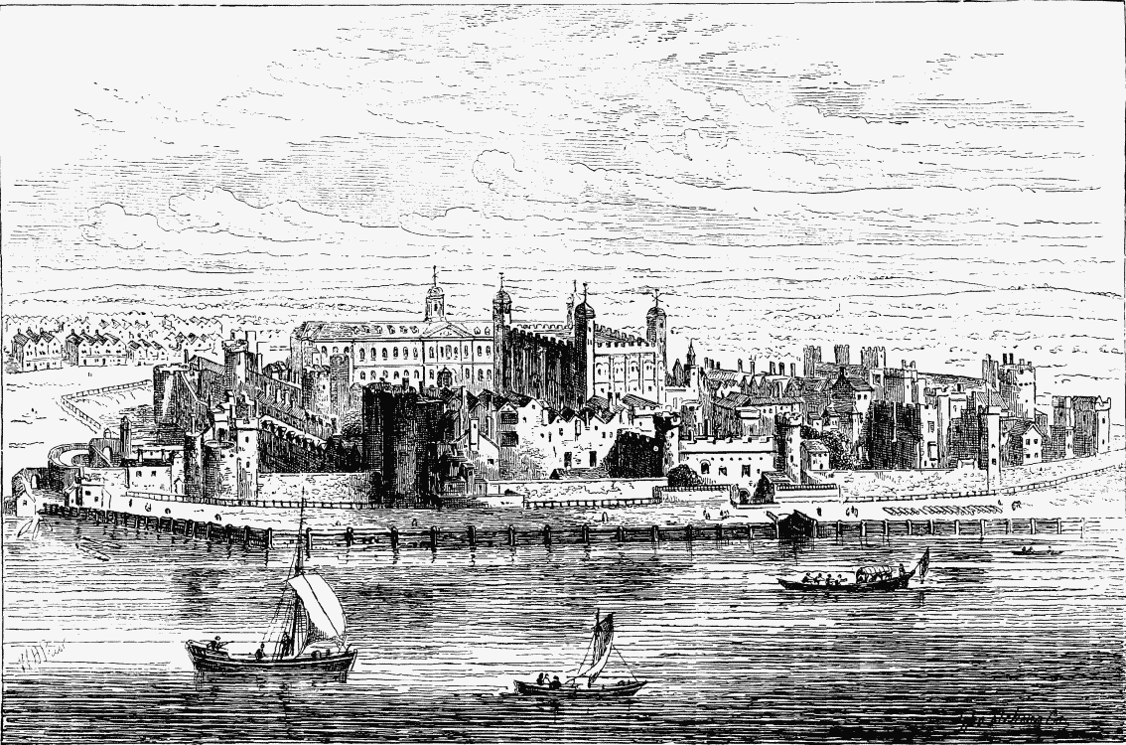
However, no matter how he feared he may let his father down, he knew he must at least try, so, after carefully checking his clothes for holes or paw marks, scraping his fingers through the tangle of hair which fell to his shoulders, and grabbing a hunk of coarse bread left over from yesterday, Robin ran out of the Tower, and towards the Navy Office buildings on Seething Lane, just west of Tower Hill.

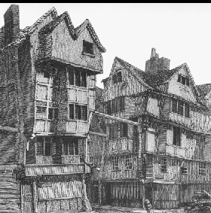
Chapter Two: Meeting Pepy’s
As he stood outside of Samuel Pepy’s front door, the sounds of the bustling, chaotic stalls and shops, punctuated by the loud cries of street traders, seemed to vanish, replaced by the sound of his heart hammering in his ears. This was the first time he had met his new master, or entered his impressive home. Nervously shaking, steeling himself to knock at the door, he noted the sign which read `Ward of the Clerk of the Acts to the Navy Board’. Each word seemed to crash into Robin’s mind, piling more and more pressure onto him. What would a man of his importance and learning make of a boy who stuttered when nervous and felt happier amongst animals than people? Robin had never felt so tense and wished he had one of his animal friends with him to calm him and give him courage. Aware that he could put the moment off no longer, he took a deep, calming breath, and knocked sharply, each rap echoing behind the oak panelled door.
Robin didn’t know how to react when Pepys himself, not a housekeeper or servant, answered the door. Robin knew very little about Pepys, only what he had heard from his Father and the street gossips; about his increasing importance in London and the rumours of his violent temper. He had however known of his Puritan background and as such he was not surprised to see him dressed all in black in a slightly old fashioned style, yet with a beautifully tailored velvet coat.
“H h h hello Sir. My name is, I mean I am honoured to introduce, um…” stammered Robin, tripping over his tongue.
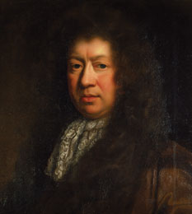
“Aha, boy, you must be my new apprentice, so pleased to meet you!” roared Pepys amicably while pumping Robin’s arm up and down in a firm yet welcoming handshake. “Please do come in.”
Robin’s immediate thought upon first seeing Pepys was that his face seemed to be trying to escape from the mass of hair of his long, curled wig. His forehead, though high and creased at the bridge of his nose, suggested wisdom, this was further reinforced by his thoughtful yet twinkling eyes. As Robin stared, revelling in his first sight of Pepys, he felt overwhelmed by relief and reassurance. A man with cheeks as rosy as his, a chin disappearing into his neck and a nose which stuck out in such an odd way could only be a good master, surely?
Realising that he had yet to reply, and had in fact been staring open mouthed, Robin grasped for the correct response. However, before he had a chance to speak, Pepys continued;
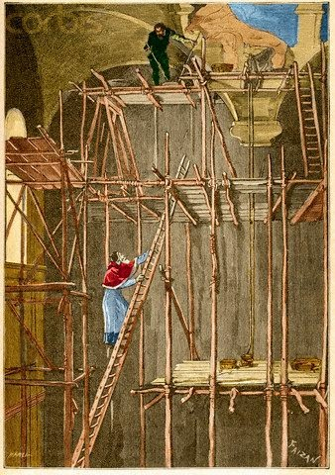
“I am off to Fleet Street to visit `Prince Henry's Room’ one of my favourite taverns, to meet a friend - a Mr Daniel Baker, perhaps you have heard of him? - No, well, he has some worrying ideas about the helplessness of this glorious city against the threat of fire, and I intend to meet with him to share my concerns.” With that he picked up some papers and swept out of the door.
Hurrying after him, Robin remained quiet, half jogging, half running to keep up with his master’s swift pace. He was rushing so fast that he barely had time to register the Cathedral with it’s massive lead roof supported by timber beams and caged by scaffolding, or the book sellers and printers who stored their paper in the crypt and surrounded the cathedral.
After the exhilarating meeting between Pepys and Baker, the rest of the day passed by in a blur of new faces, names and feelings of general astonishment at how fortunate he was to be living and learning alongside the Samuel Pepys! As they had walked through Leadenhall market his master had been greeted by so many smart looking people, asking for favours or offering him free goods that Robin began to feel important himself. He began to suspect that he would greatly enjoy the mad whirl of Pepys life. Who knew what would happen tomorrow?
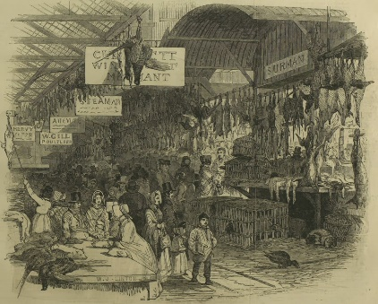
Chapter Three: Late Saturday Night September 1st 1666
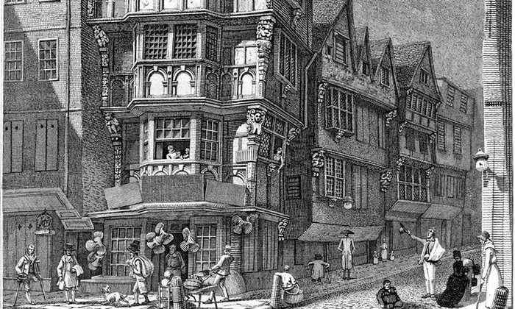
Robin had been Pepy’s apprentice for a few weeks now and although still likely to stutter or panic when spoken to directly by Pepys, he had begun to recognise the routines of the days; the stroll around the park in the mornings and a brief stop at St Olave’s church, followed by a visit to the office or Navy visitors to Pepy’s home. He had even become used to the exotic food which was served regularly as part of the midday meal such as fresh fruit and salads from vegetables grown in the Pepys’ greenhouse. After lunch would be more Naval duties then a trip to the horse races, the New Exchange for shopping or the recently re-opened theatres. Robin loved to see the beautiful costumes and hear the fantastical stories.

Pepys was, Robin was beginning to learn, a very unusual but incredibly clever person. To most people, he was a friendly, ambitious, quick witted man whose intelligence shone through his conversations. Yet this was a stark contrast to the sullen, easily angered person he became whenever around his young wife and her pets. This Pepys bickered, grumbled and moaned, temper flaring, growling and hissing at his wife’s dog and monkey as they jumped around his home wee’ing where they pleased (Robin was secretly pleased to once again be surrounded by animals, even if they were poorly trained)!
Fortunately, Pepys always had time for Robin and the other members of his household. Indeed, Pepys seemed to have no end of patience with his rebellious young clerk Will Hewer. This rascal was constantly forgiven or excused, despite his astonishingly disrespectful behaviour such as wearing a hat in the house and even refusing to go to church! However, what Robin disliked most about Will was that he would kick the poor animals if they came near him. Pepys may hiss and shout, but he had a gentle heart and would never hurt them no matter how much he disliked their habits. Robin couldn’t understand how Will could be so cruel and willing to risk his place in the Pepys’ home.
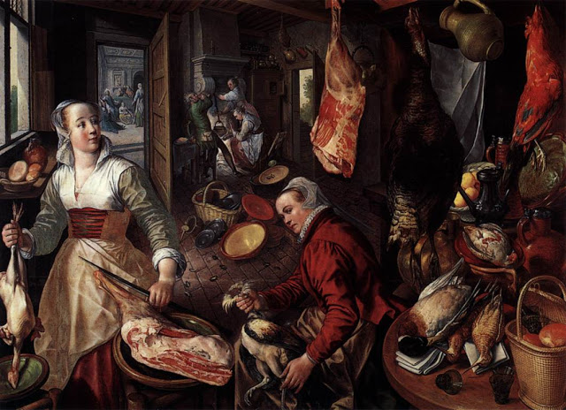

Tempers had been particularly high between the two boys this morning as the house was busy preparing for tomorrows guests. Thankfully, Will’s duties to his Mum had now taken him back home and away from trouble at Pepy’s house.
Robin had spent the day helping Pepys and after such a long day, he felt too excited to sleep so went to the kitchen to help the young maid Jane, her brother Wayneman and the cook-maid with the final preparations.
The night had turned to morning, and, as the church bell rang for 1 o’clock early that Sunday, they were preparing for bed when there was a loud knocking on the door. Jane turned to the others in confusion and annoyance;
“I’ll go and see who it is at this unearthly hour and send them packing!” she grumbled. Time passed slowly as they waited to find out who was at the door, however finally, following hushed, urgent voices, Jane burst back into the room. Her face was deathly grey, her lips pale as the moon and her eyes dull with fear. Her whole body shaking, she quickly called to Robin;
“The whole of Pudding lane is up in smoke! The Baker and his neighbours have struggled for over an hour with water from fire buckets, and scoops to pile earth on the fire, but have had to give up. Quickly tell the others while I wake the master!”
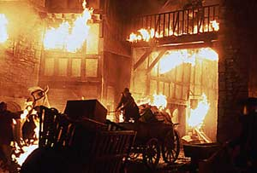
With that she dashed out of the room. Bewildered, Robin ran around the house, banging urgently on doors, shouting the news. It took a long time to rouse everyone, but once all had been woken he went to Jane’s room where he found a great deal of disorder; Jane calming Elizabeth, Pepy’s wife, who was as white as a sheet, while her pet monkey, dog and cat leapt around the room barking, hissing and squealing, and Pepys, dressed in his night gown. As Robin entered, Pepys had been looking out of the window, straining his eyes to work out exactly where the fire was. After a few moments he turned calmly to those gathered in the room and said:
“It looks to be on the back side of Mark Lane and as such is a safe enough distance for us not to worry. I met with James Howell only last week and he helped dispel my and Mr Baker’s concerns over a fire getting too large. He was confident that there's no place better armed against the fury of a fire; for as well as the water buckets that hang in Churches and Halls, we have fire squirts and the new engines. I’m sure it will soon be under control. Go to bed all of you!”
“But sir, called Jane, the messenger has been back and says…” Pepy’s cut her off.
“I have made my decision. We are safe, go to bed!”
Breathing a loud sigh of relief the room emptied, leaving only Jane and Robin. He was warily watching Jane’s face; she looked twitchy and agitated.
“What is it Jane? Why do you still seem so worried?” he asked quietly, watching over his shoulder to make sure no one had remained.
“I’m sure it’s nothing, but… well, the master is new to this area, and has only heard of the frequent small fires occurring within the city due to the candles and ovens in our wooden homes. Yet, the messenger seemed certain that this fire was different. That this might…” she left her sentence hanging in the air, unspoken, yet full of meaning.
“Tell me exactly what the messenger said just now” urged Robin.
“Well”, she began, “he said that it was at Farynor’s bakery where it started, you know him, he makes the biscuits for the Navy.” Robin nodded. “Apparently his oven had not been fully put out and the smouldering embers ignited some nearby firewood and soon his whole house was ablaze. His family escaped through an upstairs window then fled across the street, but one of his maids refused to leave and she perished in the fire!”
At this Jane sat down suddenly, her hands to her lips as if in prayer. Concern was etched over her face as the full awful realization of a lost life dawned on her. “Who will tell her family? What if she had children?” she mumbled.
Robin patted her gently on the shoulder, urging her on. Taking a deep breath Jane continued;
“Well, the fire spread quickly through Pudding Lane and carried on down Fish Hill. The Mayor, Sir Thomas Bludworth, was woken at 3 o’clock and told about the fire but when he got there he said it was nothing to worry about, yet the messenger had heard it had engulfed the Star Inn.” Having finally told her terrible news, Jane slumped in the chair, weeping softly.
Torn between his compassion for Jane and his belief in his master’s wisdom, Robin was unsure what to do. Surely a man as wise as his master couldn’t be wrong about such an important matter, a feeling reinforced by the similar approach by the Mayor. No, he could only conclude that the messenger had overreacted. Unwilling to hurt her feelings by merely dismissing her fears, Robin suggested that they go to their beds now but wake in a few hours for an update on the fire. Reluctantly accepting his decision, Jane turned and slowly made her way to bed. Despite the exhausting day the excitement hindered Robin’s sleep until he eventually drifted into a troubled slumber.

Chapter Four: Early Morning Sunday September 2nd 1666
Robin woke groggily, his body thick with sleep and unwilling to move, his ears ringing with the tolls of the church bell, announcing seven o’clock. Fighting the heaviness in his eye lids, he quickly splashed his face with cold water and made his way to the kitchen for an update on the fire. The moment he approached the room, he sensed something was wrong. As he opened the heavy wooden door to the kitchen the usual cacophony of sounds such as the clattering of pans and kneading of bread were eerily missing. Instead the kitchen was filled with sobbing women, wringing cloths and whispering to each other.
“What is it? What has happened?” Robin asked the nearest wailing servant.
“It’s the fire! Will has just returned telling us that it has spread terribly, having fed from the hay and animal feed piles in the yard of the Star Inn at Fish Street Hill. From there it went into Thames Street and has grown too fierce to combat with water buckets and squirts. Furthermore, the Mayor refuses to pull down the buildings in the path of the flames because he would have to pay for them to be rebuilt, yet without this the fire will not be deprived of fuel and shall simply continue. Even worse still, the City's waterworks that pump the desperately needed water has also been destroyed!” At this final screeched sentence the maid broke down into a heap on the nearest chair, weeping uncontrollably into her skirts.
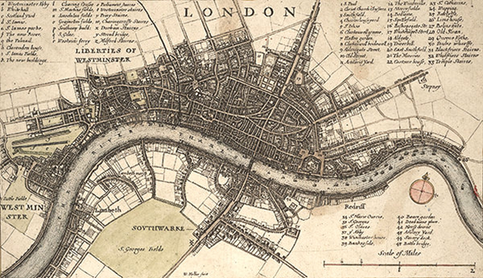
Robin was struck by the stupidity and selfishness of the Mayor. Without the fire gaps the fire would spread out of control, doing far more damage than anyone could possibly imagine fueled by the contents of the riverfront warehouses which were bursting with oil, hemp, hay, timber, coal and spirits. An awful thought crept into his mind; had Will made this up? It seemed highly unlikely that such a respected man as the Mayor would be so self-centered and idiotic as to have acted this way. He had to find out. Running out to the street Robin was shocked to see the distant glow of flames and an evil, black curtain of smoke which had crept towards the house during his sleep, dragging the faint scent of burning with it. In that instant Robin knew that he must overcome his nervous, shy side, and instead he must take control. If the flames and smoke had travelled that far in just a few hours, then it really was a threat and not just another brief candle fire which could be put out almost as quickly as it began.
Robin returned to find Jane and commanded her to wake Pepys. Seeing his determined face and set jaw she appeared to gather strength and quickly went to his room. Meanwhile Robin began to order the household to collect a few key belongings together in case the need arose to flee the house. As he raced around gathering clothes and food supplies, Robin realised that the foolish dog, cat and monkey must also be taken to safety. After all, how could he, son of such an important animal lover, dare consider leaving the defenseless animals to their certain death? Swooping down to grab a blanket and create a sling for the monkey, Robin harnessed the frantic, wriggling creature to his back, grabbed a bone to lead the dog and cat to safety and continued – with great difficulty but determination - grabbing items for his master.
Within minutes Pepys had come downstairs, immaculately dressed in his usual black, despite the urgency, his keen eyes alert and assessing the situation.
“What’s this? Jane tells me that over 300 houses have burned down already, and that the fire is now making its’ way towards London Bridge. Is this true boy?”
“Yes Sire, it has grown so intense that flames can be seen from a quarter of a mile away in all directions.” replied Robin without his usual nervous stammer.
“In that case let us go to a high point in the Tower so I can see for myself.”
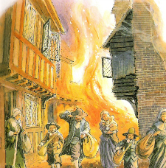
Relived that his master had not mentioned the animals shadowing him, and struggling with the nervous monkey tied to him, Robin and his master hurried closer to the fire which had been raging for nearly 7 hours. Nearing the river Thames, they were horrified to see that the fire had progressed half way across London Bridge. Stunned by the sight Pepys halted, looking intensely across the bridge. Slowly, understanding dawned as Robin recognized the area as being where they had visited a little boy only last week. The boy, Mitchell, had lived in his home on the bridge with his mother Sarah. However, now, where their home had once stood, was a blazing inferno, flames leaping about like a crazed animal, stretching and whirling as if trying to escape from a dragon’s mouth or, he thought dismally, from the very belly of Hell itself!
Watching the fire, Robin’s senses felt as if they were under attack. The sight of the monstrous flames struck him with fear whilst his nose began to sting with the bitter smell of burning. At the same time his ears were tormented by the shrieking of women and children desperately seeking each other while trying to save whatever they could carry, trying to make themselves heard over the noise of the crackling, hissing fire and the reverse peal of church bells sounding the fire warning. Robin watched as people had to choose whether to help neighbours with their fire-fighting efforts or try to save the goods from their own houses. The river was already beginning to fill with boats laden to overflowing with property rescued from houses which had burnt down. Alongside this were the shouts of Profiteers trying to make money by hiring out their carts and boats at extortionately high prices, preying on the desperation of those fleeing.
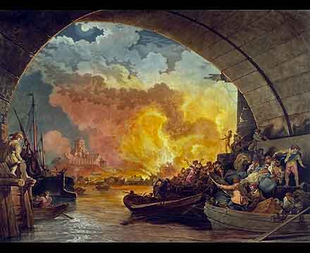
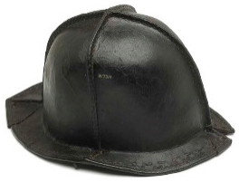
It was 8 o’clock in the morning when they reached the Tower. It was as dark as dusk. The smoke increasingly covering the already polluted sky. The wind had blown into a howling gale, gusting so hard Robin struggled to stand, and the dog, which until now had bounded energetically around his feet, lurked quietly, it’s gentle whimpering whisked away by the violent gusts. They were instantly greeted by Robin’s Father who, after safely depositing the monkey in a cage and giving water to the dog (the cat having slunk off somewhere earlier), told Pepys that the fire had engulfed both the Church of St. Margaret and St. Magnus. This seemed to trouble Pepys gravely, and Robin felt compelled to question why.
“People head towards Churches in times of fire, firstly because they are made from stone which does not burn, and secondly because they are key storage places for firefighting tools. If flames have demolished Churches then that means loss of both lives and firefighting equipment! I must go with all speed to report to the King and his brother the Duke of York, and ask for their help.”
Robin’s Father grabbed Pepy’s coat as he turned to leave. “Before you go, there is some good news at least; the fire’s journey across the bridge has halted at `the Square’ (Robin knew this to be the name for the gap in the shops about a third of the way down on the bridge, made in the last great fire).”
Robin realized the importance of this straight away, as it meant that Southwark on the other side of the Thames should be saved from destruction and the raging flames confined to the City of London, on the north bank. With thanks, Pepys signaled to Robin and strode purposefully to the water-side to get a boat to Whitehall.
Having finally found a boat willing to take him Pepys turned to Robin:
“I cannot take you to the King, I need you here. Your Father has shown me that the fire is now as far as the Steele-yard, fanned by the steady wind which is driving it into the City. With everything so dry after the long drought, I must ask you to stay and try to help in any way that you can. Reassure people that help is on its way but that they must keep on fighting the fire with all that they have available to them without placing themselves in danger. I will try to convince the King of the necessity of using firebreaks to starve the fire of the wood it needs to burn and stop its’ path. I cannot believe that he knows of the intensity of the fire or the Mayor’s selfish stupidity! Above all, encourage any who are fleeing to fight the fire for as long as they can.”
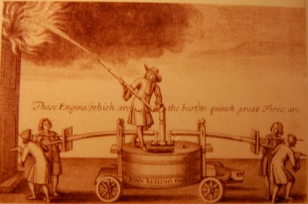
Chapter Five: Sunday September 2nd 1666
Disappointed that he wouldn’t be meeting the King, but determined that he would make his master proud, Robin set off, hoping to support the people nearby who he could see had managed to locate one of the large containers of water which Pepys had referred to as a `fire engine’. It was being dragged on a large sledge through the streets by a team of men on horses, intent on filling the pump from the Thames. As he moved closer to the blaze, his heart fell as he saw the tortured, panicking faces of the people rushing in the opposite direction of the fire; towards either the Thames or the City gates which led to the fields outside of London. Ignorant of others and intent purely on self-preservation, they had abandoned friends and neighbours, grabbing their meagre belongings and running.
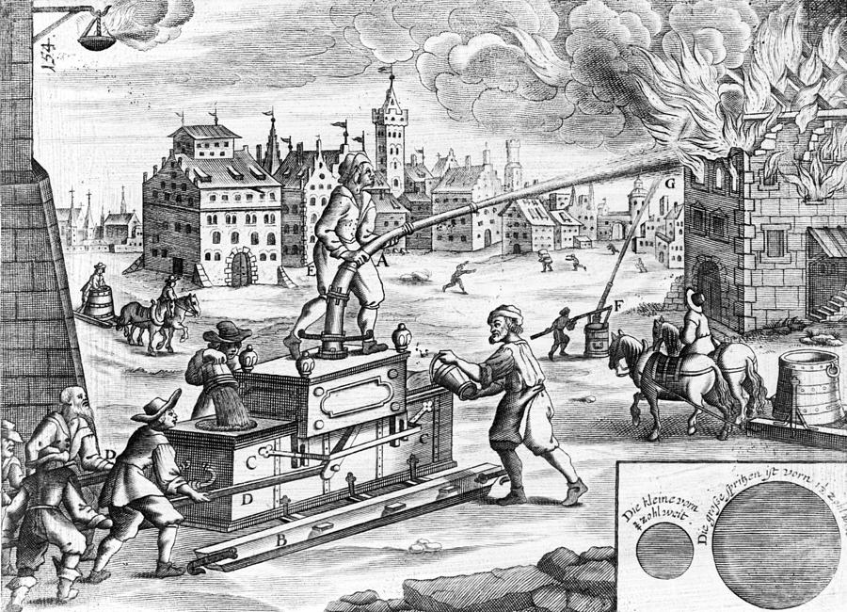
Reaching out to a boy of similar age as he rushed past, Robin tried to persuade him to stay and help fight the inferno. The boy simply turned his panicked face and stared at him as if he were talking another language before unprizing Robin’s fingers from his arm and fleeing.
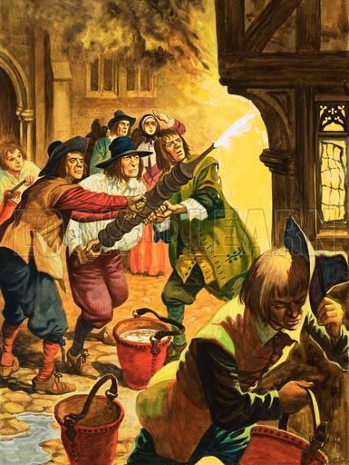
Robin panicked. If he couldn’t persuade a boy to stay and help, then what luck would he have with grown-ups? Becoming increasingly overpowered by fear and noise, Robin began to feel dizzy. Nearby horses, parted from owners in the confusion, neighed and galloped wildly, trying to find safety, their hooves clattering on the cobbled streets, each sound more piercing than the last. Houses creaked and groaned as they fell, consumed by the fiery breath of the monster which was beginning to conquer the City. As he stood, trying to decide what to do next, Robin watched flames from the building in front of him spitting furiously, causing sparks to jump onto other previously untouched homes. Roused from his daze by an enormous splash he watched, as if in slow motion, as the fire engine fell into the Thames, having been lowered too far in an endeavour to pump water from the river that had dropped several levels due to the recent drought.
Dismayed and desperate, Robin quickly turned and headed for the Church to collect a fire squirt. Having battled through the smoke, ash and screams, he found that no squirts were left, and those which were being used were useless against the blaze as they only held 2 litres of water and needed constant refilling. During his search he overheard that such catastrophes weren’t just here, but that fire equipment all over the city was missing or damaged, vanished from the churches in the 30 years since the last big fire. Grabbing the only equipment available - a leather bucket - he began to search for a source of water. His heart hammered painfully inside him and pounded in his ears as he became aware of people breaking into the wooden water pipes to try and get the water out, causing the water to disappear into the hot earth.
Having failed with one pipe, the men began to demolish another, yet with the same disastrous results. Pulling himself to his full height, and imagining himself as a Lion tamer or other such fearless person, Robin screamed furiously “Stop!” We must work together! Make a line using fire buckets filled from the river!” Robin began to organise the men, who, once past the initial surprise at being ordered by a mere boy, had begun to realise the uselessness of their efforts and the sense that he spoke. Within moments people had started to form a line, scooping water from the Thames and passing buckets along like a human chain. Whilst more effective than previous uncoordinated attempts to quench the fire, Robin saw that with each pass, water was spilt and the fire continued to rage. Loosing heart, Robin felt sweat trickle down his back, and the grime of the smoke blown onto him caking his skin, making slippery trails down his face and neck. Powerless and without his master’s advice, Robin began to wonder if he was destined to die amongst the crashes and screams.

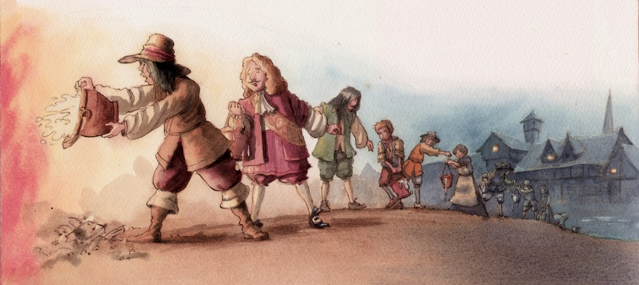

Chapter Six: Sunday night
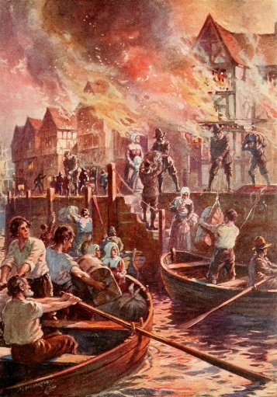
On the edge of despair Robin became aware of the dog barking furiously. Wondering what had taken its interest from chasing the buckets of water and stealing drops as they fell, Robin’s eyes followed the dog’s gaze, finally falling to the boats on the water, yet of the many leaving, one was coming towards the city and its’ insatiable fire. Fearful of raising his hopes only to have them dashed Robin tried to continue passing buckets, yet, as the boat got closer the barks became more excited and he could see a joyous sight; his master had returned. Hurriedly shoving the bucket to the person next to him, Robin left the chain and rushed to meet Pepys.
“Aha, boy, quick, there is little time” called Pepys over the clamour caused by the fire and failing to introduce his companion in his haste. “We must go straight to the Mayor. The King has ordered that all the houses in the path of the fire should be pulled down with fire hooks to create a 'fire-break'. Bludworth cannot refuse now!” Robin could hear the admiration in Pepys’ voice as he spoke of the King.
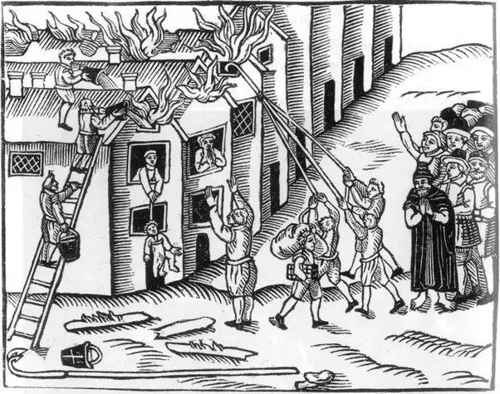
With no time to waste, Captain Cocke (Pepys previously unintroduced acquaintance) lent them his coach and the two of them sped to the Lord Mayor’s house. On the way they witnessed the rampant spread of the fire, flames consuming homes, and thieves stealing from empty buildings. As they approached Watling Street they witnessed the confusion and disorder. The Mayor was shouting orders but people were ignoring him, choosing to save themselves and their possessions rather than help the foolish man who had had the chance to stop this from getting so out of control.
“What news?” shouted the Mayor to Pepys over the crackle and yells. “I have started pulling down houses myself as no one will obey me and I am so tired. I need more men and rest”.
Once Pepys had passed his orders, adding that the Duke of York had promised more soldiers to come and support the firefighting efforts, the Mayor seemed to calm.
“Thank Goodness for that” he wheezed.
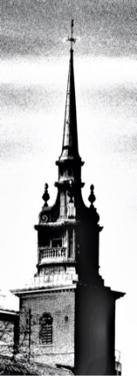
Pepys, certain that he had done all he could at this time, set off home with Robin trailing numbly behind him. The meal that followed passed in a blur. Voices seemed to rise and fall around him as Robin tried not to give in to the tiredness caused by the late night and recent events. Although briefly interrupted by the local wine merchant’s wife enquiring about relatives whose house had been burned, the dinner seemed to continue as normal. Taking advantage of Pepy’s decision to walk with his guests to the top of Barking steeple to check on the progress of the fire, Robin crept up to his bed and gratefully fell into a deep sleep.

Chapter Seven: Monday morning
Tossing and turning, Robin’s dreams were tormented by sounds of people shrieking, horses galloping and arches of fire crackling as they jumped closer and closer like a giant poisonous toad with flames, not poison bursting forth, intent on burning all it could reach. His breath seemed to come in rasps as the fire in his mind scorched his throat, drying it until it resembled the parched ground which had been sucked of every ounce of moisture by the persistent drought. The world seemed to shake as buildings crashed down all around him, moving him violently side to side, then he heard a voice calling “Robin, wake up, we must leave. Robin, you must wake up!” Ripped from his dream by the realisation that it was Jane’s voice urging him into consciousness, he became aware of his surroundings.
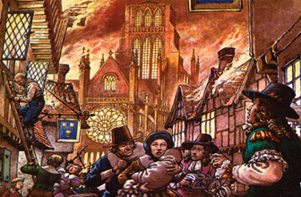
“The fire has continued to spread. The master has ordered us to pack up the rest of the house and leave. It is already getting dark so we must hurry.”
Fully alert Robin ran to Pepys’ office where he was told to take his money and iron chests into the cellar for safety while Pepys himself prepared his gold and most important papers to travel in the cart sent to him by Lady Batten. As Robin helped Pepys load the cart, he watched his master warily choosing which of his precious collection of treasured books and manuscripts should be saved and which he dared risk leaving. Robin had few belongings of his own, so it was only when Pepys announced that he would need to leave his collection of instruments that he realised how desperately hard this must be and how Pepys might be feeling now.
Once packed, Pepys told Robin to return to his Father while he transported his goods to safety. So it was that at 5am, Robin was walking the streets, past flames which were ferociously licking at the city’s churches, trying to ignore the clanging of the bells ringing to warn all of the fire’s progress whilst pushing through carts and huge crowds of panicking people blocking the narrow roads and alleyways.
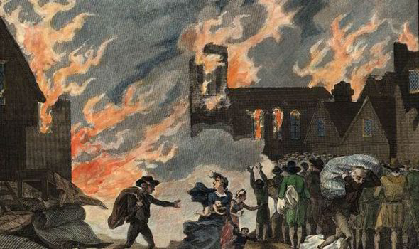
Throughout the day, Robin was kept busy helping his Father calm the animals and do all they could to keep them safe, although he couldn’t believe that anything could get through the Towers’ recently improved defences and thick stone walls. As he worked he briefly felt a strange sort of gratitude that there were so few cats or dogs in the city in the path of the flames, as so many had been killed by those who thought they were the cause of the plague last year. Yet it wasn’t just the animals that Robin knew were suffering and fearful. Watching the bustle of people all around the Tower streets trying to save their possessions tore at Robin’s heart. These petrified people, scurrying through the streets, were unrecognizable from those who, only yesterday, were happily selling their goods and living ignorant of what was about to happen.
Robin’s thoughts turned to Pepys household; of the maids and the people he had begun to think of as friends, or even family. How were they doing? Were they safe? What of Jane? As his mind whirled he was appalled by the thought that not everyone was as fortunate as him. Those with families were helping each other, yet what of the elderly and the sick or those alone following the various bursts of plague? Would these terrified creatures be remembered by those around them amidst the confusion, noise and dust?
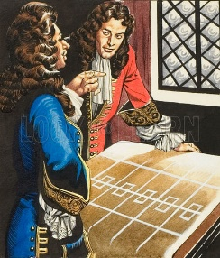
Returning to his home in the Tower, Robin searched hurriedly until he located his Father, huddled around a table with other men, deep in plans to protect the animals within the Tower. It took a while before his father noticed him, each second dragging by, with Robin increasingly alert to the chance of more loss of life due to lack of awareness and support. Eventually the Keeper turned and, glancing at his son, silenced his colleagues.
“What is it? Are you hurt?” he demanded, keen to ensure his son’s safety.
“No, no Father, I am fine”, Robin answered impatiently, “yet what about the ill and old? Who is helping them? I know that King Charles has ordered that navy rations stored in the docks should be given to those who had fled the city, but what of those who were unable to escape?”
His Father’s face registered a myriad of emotions, chasing swiftly one after the other; first relief, then shock, anger at his own lack of foresight, quickly replaced by pride in his compassionate son. After briefly turning and mumbling to his colleagues, his Father stood facing Robin and, laying his hands on his shoulder, said
“My duty lies here, ensuring the safety of the beasts, however, you are of an age where I feel you can be trusted to lead. I want you to organize some men – I will advise you on who – and begin a rescue operation. I am proud of you son. Be careful!”
Robin felt his cheeks glow. Never before had his Father shown such trust, such belief in his son. If he had had more time perhaps he would have reflected on whether this was caused by circumstances or whether he had in fact matured in the weeks he had been in service as Pepys’ apprentice. As it was he stood tall, and upon hearing his Father’s advice, swept quickly out of the Tower and into the streets burning ravenously below.
Within the hour he had organized his team to search through the streets and work in pairs to aid the sick and old as well as those who were already desperately carrying friends or family on carts or their beds as far from the fire as possible. Had it not been for the seriousness of the situation it may have seemed funny to onlookers to see a monkey carrying a blanket or pillow and a boy ordering grown men, while a dog chased around his heels, but as it was every pair of hands was urgently needed. This approach worked at first, yet by late morning an order had been given by the King that carts could not be brought near to the fire; in an attempt to stop the streets being crammed full of carts of goods which were stopping the people themselves from fleeing to safety. This meant that people had to be carried, a process which initially slowed the rescuing down. Sensing that the people needed rallying, Robin stood high on a barrel and called over the noises of the fire and people pushing and shoving;
“People! Why do you think only of yourselves in this terrible time? We are Londoners, the best, most noble people of England. Should we be fighting each other so that we can escape, or helping each other so all may flee to safety? Think of the King. He values our lives so highly that he has banned carts so that we, not our insignificant possessions, can be saved. Look at these small animals, even the monkey is doing its bit to help. Is it more of a Londoner than you?”
After a brief silence, punctuated only by the hiss or crackle of flames, a mumble of voices began to rise. Amidst the chaos and terror, the fact that their beloved King Charles was thinking of his people and supporting them in their hour of need, began to create a glimmer of hope and unity. Those who had been thinking solely of themselves began to view London as a whole, peopled with men and women in similar situations and this led to more volunteers and a swifter process.
Buoyed by this and the establishment of eight fire posts, from which the firefighters' efforts would be directed, as well as thirty foot soldiers assigned to each, alongside the rumour that the King had even been seen immersed in the battle against the fire himself, Robin began to feel that an end to this awful ordeal was in sight.
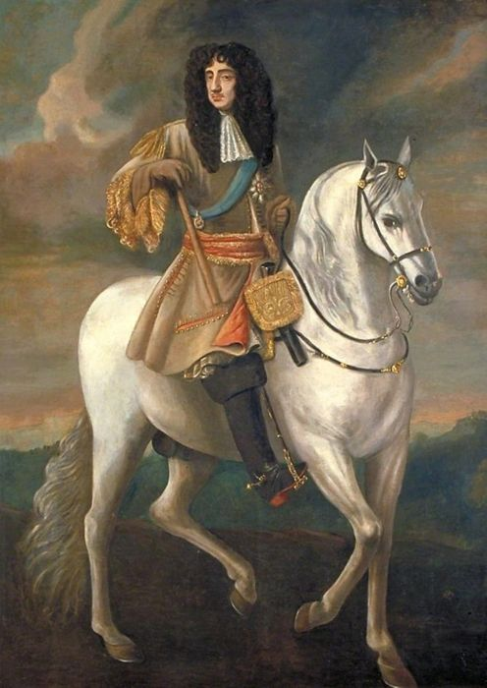

Chapter Nine: Monday late Afternoon
As Robin supervised the rescue of the less fortunate and tried to stop the evil gossip concerning which of England’s enemies had caused this fire, his exhausted mind began to wander and he felt himself thinking of how his loved ones were faring. Had they managed to escape in time? What of the Tower and his Father, how were their efforts progressing? It had only been a few hours, yet with the fire moving at this rate pushed forward by the wind it could easily have crept close to the Tower. Now that enough men had joined the evacuation efforts he could slip away to find out!
As Robin rushed back to Pepys home to check on his friends before he continued to the Tower, he gathered an increasing sense of the urgency to stop the path of the fire. His feelings threatening to overwhelm him he wondered what more he, a boy, could do against the ravishing monster of the fire? Feeling downhearted, Robin updated Pepys who had been joined by his Navy friend; Sir Pen.
“The house is virtually empty so we are off to my neighbour, Mr Batten’s, home. He claims to have hit upon a clever idea. You are welcome to join us”
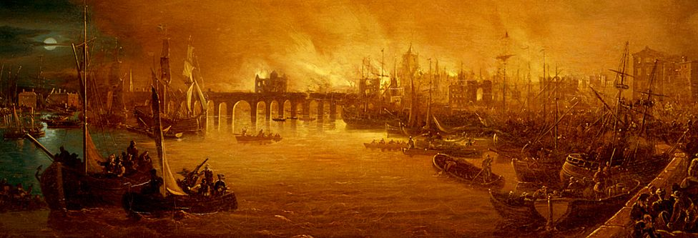
Intrigued Robin followed his master into Mr Batten’s garden. His curiosity turned to confusion when he was asked to help Mr Batten dig a pit for his wine. This seemed to Robin to be a very odd thing to do, so Pepys explained that due to the great expense and the likelihood of the home burning, burying precious items like wine, was the only way to keep them safe.
“But are you not concerned that it will be stolen sir?” Robin asked quizzically.
“If thieves are so desperate as to risk their own lives for my wine then they can have it, and I hope they choke on it!” growled Mr Batten.
Seeing that they had overstayed their welcome, Sir Pen, Pepys and Robin returned to the house where they worked together to bury Pepys own remaining items; some important papers, wine and expensive parmesan cheese.
Leaving the men to sit glumly in the garden, Robin began the hot, dangerous journey to the Tower to ensure his father was well, and to gather more news on the fire. With each deserted and devastated street that he passed, he was greeted by a scorching wind bringing the smells of burning materials and the sounds of buildings as they collapsed. Looking around at the wreckage he saw the hopeless efforts of those with buckets of water and fire hoses, and the wrestle of men with fire hooks, tearing down buildings only for the flames to leap over the gap, driven by the intense wind and continuing relentlessly in its path of destruction. Sometimes a single fire-drop would move over the space of six houses and so begin another blaze. Robin found himself thinking back to his earlier visit with Pepys to his Father and the comment about the fire halting at the gap on the bridge, thus saving the other side. As a crash sounded nearby, followed by a deafening explosion as a warehouse collapsed, Robin had an idea. If a larger gap could be created between buildings, and more quickly than was possible with fire hooks, they may be able to get some control of the fire, but how? He thought of how Evie the elephant would help his father by pushing down large fences or walls with her amazing strength, yet quickly dismissed this idea. He could never think of risking his animal friend’s life, and how could one elephant help against such a vast fire? Continuing to ponder the idea, he vaguely remembered Pepys mentioning a substance used by the Navy called gunpowder. Perhaps this would work? He must return to Pepys straight away and share his idea with his skilled master. If anyone could make his idea work then it would be the man rumoured to be the `right hand man of the Navy’!
Eager to convey his idea Robin forgot formalities and swiftly told Pepys his belief. Pepys, startled but quick witted as ever grabbed Robin by the shoulders, pulling him forwards in an awkward hug.
“But of course! You have it my boy and that is just what we shall do! I must find the King and suggest he uses gunpowder as this will cause wider gaps and deny the inferno its fuel.” Hastily excusing himself from his friend, Pepys bade Robin to follow him through the smoke filled gloom until he reached the King.
Robin wondered what the King would be like. What would this man lovingly termed the `Merry Monarch’ due to his love of extravagance and expensive things, be doing? Would he be safely waiting for news, somewhere far from the action as this image implied? Whilst aware that people often didn’t live up to expectations and that sometimes there was truth in rumours Robin was nonetheless still hopeful.
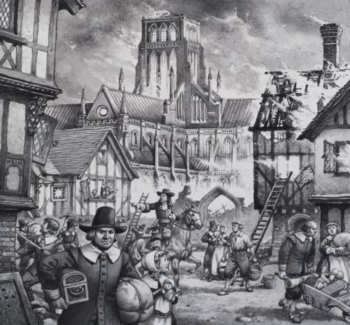
It was thus a great relief when they found the King; dirty and mud stained, not haughtily standing back, but immersed in the firefighting efforts, passing buckets of water and wielding an axe to create firebreaks. Impressed by the actions of this man, and with a renewed burst of loyalty to the King, Robin bravely stood tall and proud as Pepys shared his idea.
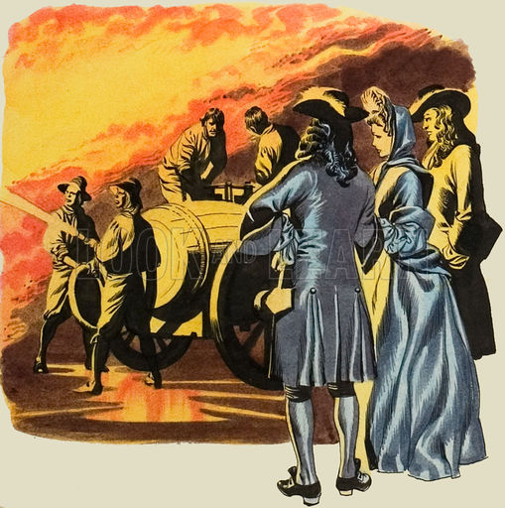
“But is it possible? Can you be sure it would not further the chaos? How will you control the explosions? What of the people whose homes we will be demolishing?” queried the King, surprising Robin with his insight, compassion and common sense.
“It will need supervising Sire, but the Navy have been using gunpowder with increasing success and I feel certain that it can be done” replied Pepys.
The King looked briefly torn, presumably weighing up the chances of success with the possibility of furthering the path of the fire. Sensing his uncertainty Robin told him of how people have been buoyed by the King’s orders and actions so far in caring for his city.
“Your courage and decisiveness has given us hope and led your loyal Londoners to stop thinking purely of themselves but, like you, to abandon status and work together as equals to help those in need. I understand that it seems backwards to cause more devastation in order to stop it, yet I know that my Master would never allow the use of gunpowder if he wasn’t sure that it would work. With your support people will willingly agree to their homes being blown up if you tell them that it will end this destruction.”
This final plea by Robin bought a sparkle to the Kings’ eyes and, turning resolutely to Pepys he ordered that he make arrangements without delay.
Within hours Pepys and Sir Pen had begun discussing preparations for blowing up houses in the path of the fire, however Robin was disappointed that it would take time for plans to be put in action due to the need to gather skilled men and resources from as far afield as Woolwich and Deptford. He kept thinking to himself, `could they get the gunpowder working in time? Did they stand a chance or was this just a last, empty attempt to overcome the seemingly indestructible fire?’ Whatever the answer, Robin knew he must get to his father and provide more help before it was too late.

Chapter Eight: Monday Evening
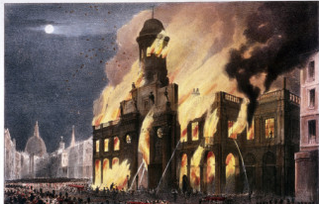
By now the flames, which had briefly appeared to be losing their battle, had pushed north into the heart of the City, growing with each building they conquered, devouring Gracechurch Street, Lombard Street, and heading towards the wealthy area of Cheapside. Whilst helping one elderly man, Robin talked to the minister Thomas Vincent who had joined him in his endeavours. He couldn’t believe the news (and wouldn’t have had it not been from such a reliable source) that even the Royal Exchange had fallen victim to the rage of the fire.

Robin had visited the Exchange often with his master and when he had been there it had been a towering two tiered building, majestic not only due to the grand trading floor, offices and shops which were placed around an open courtyard where merchants and traders could meet and conduct their business, but also due to the statues of past Kings which graced it. Thomas shouted above the noise of the fire that the fire had quickly entered the building and run round the galleries, filling them with flames; then descended the stairs and filled the courts with sheets of fire causing the statues to crumble with a dreadful and astonishing noise. Robin felt that had it not been so hot with smoke and the heat from the fire, his eyes would have filled with tears at the senseless loss.
However, it wasn’t just this which concerned him, for as people came by he grasped wisps of conversations and updates and there were rumours gathering of suspicious foreigners setting fires. The blame was mainly focussed on the few French and Dutch living in the City. This distrust had begun to lead to these people being attacked. Although they were England's enemies in the War, Robin could not understand why in this time of struggle where everyone should be working together to put the fire out, people were trying to place blame!
Cautiously making his way back through the city, past fleeing families, cradling their few belongings and keeping the river Thames to his side in the hope of decreasing the danger, Robin was shocked to see that the river was crammed full with all barges and boats hired out (no doubt at extortionate prices Robin thought dismally). Watching the progress of the fire as he battled through the smoke filled streets, Robin’s stomach lurched as he realised that the blaze had gained momentum since the afternoon and appeared to be blazing hotter and more fiercely than before. It was as if he had been physically punched in the stomach when he heard that the flames were now 300 yards from the Tower… and his Father! His worst nightmare was coming true.
Running blindly now through the alleys and streets, jammed full of fleeing Londoners, ash falling like snow from the burning buildings, sticking to his face and eyelashes, grey against a sky flaming bright as day, he could think only of his Father. As he neared, he overheard snippets of conversations held in shouts over the commotion. With each piece of good news came another blow to the city; Fire-fighters had managed to prevent Westminster School from being totally destroyed yet only after it had been badly damaged, and the General Letter Office - the only way to get news in and out of the city - had been destroyed and thus London was now cut off, with no communication except from the desperate masses fleeing the ravages of the heat who were unwilling to stop to talk.
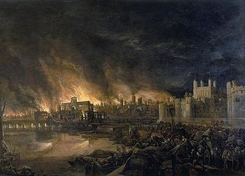
Robin felt disloyal that he could spare no feelings for those affected as his thoughts were focused solely on his Father. Finally arriving at the Tower he could see that extra fire engines had been summoned to protect it. Battling through the buildings Robin at last found his Father and, following a brief hug, he asked how he could help.
“Thankfully His Majesty has heeded my request for additional engines so we should be safe enough son, however I am unsure whether it was because of the importance of the building and animals or whether the King had his eye on the future” he commented cynically.
“What do you mean?” asked Robin, puzzled.
“Many of London's most wealthy citizens have stored their money and valuables in the Tower for safekeeping and perhaps he is thinking of the cost to rebuild the city when the blaze is finally extinguished, after all, he has only recently returned to the throne, how could he alone pay for all of this?” At this he waved his hand at the devastation around him, broken homes, equipment and churches.
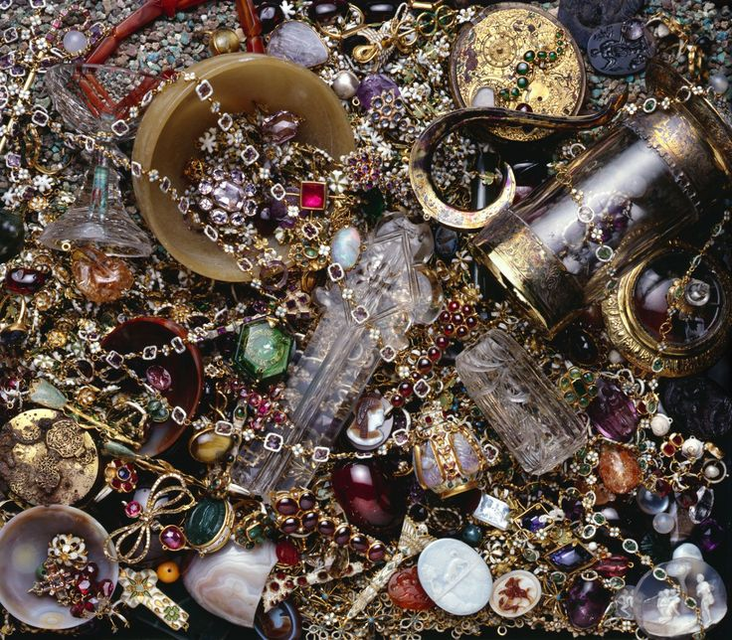
Robin refused to believe that the man who had shown such wisdom in his orders regarding the fire, and been so caring towards his people when Robin had spoken to him, would be so callous as to consider the protection of money and goods over the beautiful building and its inhabitants, and quickly shook off his Fathers remarks, attributing them to tiredness and fear. Content that his Father was safe, Robin explained how well the work had gone, rescuing and removing the sick and the old. Again, the look of pride shone in his Father’s eyes making Robin glow from within, yet he did not have the luxury of enjoying this feeling for long as his Father was once again called to return to his duties as Keeper. Reluctantly realising that he had helped as much as he could and now it was just a case of hoping the gunpowder use began soon and was successful, he turned slowly and having checked on his beloved animals, once again pushed through the crowds to return to Pepys as this was where he could be most useful.
When he arrived at Pepys home the house appeared deserted, but eventually Robin found his master sat eating.
“You are welcome to join us” he said, briefly acknowledging his wife’s presence in the room. “However, I’m afraid it is just what was left of yesterday’s dinner, and is cold as we have neither fire nor dishes.”
Seeing the food Robin realised that he had not had the chance to eat since early that morning, and suddenly felt so ravenous that he would happily eat off the floor if need be! Tucking into the cold meats and slightly stale bread, Robin updated his master on the fire and heard of Pepys arrangements for the household.
“We are now unable to do more than wait I’m afraid, so I strongly suggest that you have a nap. I intend to rest on Will’s quilt in my office as all our belongings have been taken to safety. I will wake you if there is any news.” With that, Pepys finished his meal and walked away, his steps heavy and his back stooped as if carrying a great weight on his shoulders.
Unsure whether sleep would be possible as he felt so anxious, but knowing that he would be of no use to anyone if he did not at least rest, Robin, the dog and monkey, curled up together in a corner and slowly gave in to their exhaustion.

Chapter Ten: Late Monday Evening
While Pepys had been busy making arrangements, the fire had also been active. Wreaking havoc it engulfed building after building, endless in its hunger, and devoid of soul. It ravenously consumed people’s possessions and livelihoods before moving on. Rearing up, looming terrifyingly over the city, people held their breath hoping the mighty fire would spare them, but swiftly fled as it once again leapt from home to home, racing ahead of the fire fighters. The heat had become unbearable and the noise was equally so; it was as if its’ endless cackle was laughter aimed at the helpless onlookers. It was like an evil creature sneering at the misery of it’s victims before moving on to create further loss and damage. The smoke climbing from the multicoloured flames rose not only up but also out, enveloping all around it in a sinister grasp. It’s dirty, ash filled fingers clawed over the individuals standing bravely doing battle with it, but the evil monster not only burnt their skin with its’ flames, but the thick clouds of smoke crept into their lungs and squeezed the breath from them forcing them to cough and abandon their efforts.
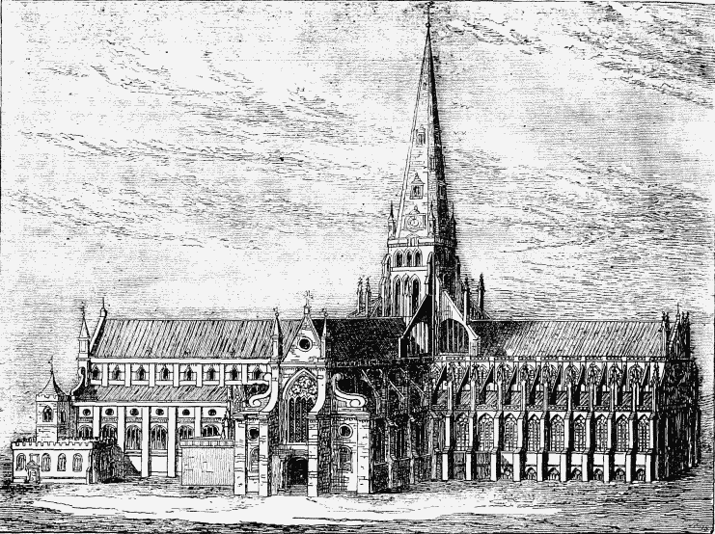
It was with mixed feelings that Robin learned that many citizens had gone to St. Paul’s Cathedral to escape from the fire, because it was made from stone, and that Will Hewer was one of those people. In one of the lesser but regular fires, contained to a house or a street this would have been wise, yet on hearing that the fire’s aggressive attack, driven by the ferocious wind, had now moved to focus on the Newgate and Ludgate prisons, destroying both, and was currently travelling along Fleet Street towards Chancery Lane, he questioned this thinking. The Cathedral had been covered in timber scaffolding on his last visit and was surrounded by wooden stalls. Not only that, but with the paper which was stored inside and all of the belongings which had hurriedly been stuffed there would the stone provide enough protection? Without thinking his feet leapt into action, once again dashing towards the fire, battling against those still running for their lives.
Moving blindly through the maze of alleys towards St Paul’s time appeared to slow. No matter how fast he moved he never seemed to arrive. Everything looked so different as he raced sightlessly through the ash filled darkness illuminated only by the unnatural orange glow from above. As Robin ran he glimpsed soot streaked people searching for a familiar landmark to aid their escape, yet finding only flames and rubble. He was beginning to fear that he had become lost when he finally stumbled out into the lane opposite the building. It was with a sense of doom that he discovered that the fire was surrounding St Paul's Cathedral. He stood aghast, rooted to the spot, watching helplessly as the flames licked at the scaffolding. All of a sudden, a sound rose through the air like a crack of thunder, and abruptly flames weren’t just licking but biting down, ferociously tearing through the buildings. As each second past flames leapt higher, wider, hotter. Chunks of charred wood cracked and flew into the air; huge blocks of ash, which would land on a nearby building and start a new fire or fall down in flaming planks, threatening onlookers.
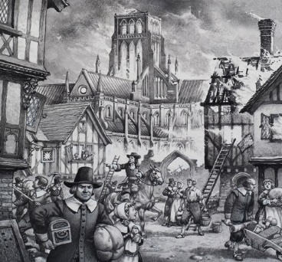
Shaken out of his trance Robin became aware of the shrieks and screams as those previously seeking safety inside were now desperately pushing and shoving their way out, trampling over each other in their fear and ignoring any who had fallen. Staring at the crowds pouring out of the cathedral Robin’s eyes searched for the familiar face of his housemate, yet Will was nowhere to be seen. Had he taken his Mother in to safety but was unable to help her get back out? Torn by his desire to survive and his concern for his troublesome friend, Robin’s compassion and empathy eventually won the struggle, forcing him to consider how best to enter the burning building. Grabbing a rag dropped in the mayhem, Robin soaked it in water from one of the leather buckets and held it over his head in a protective shield. Ignoring bewildered gazes of those around him he slowly, carefully made his way into the building, ever watchful for falling embers and the inferno engulfing ever increasing amounts of the building.
At first he couldn’t hear anything over the loud roar, nor see anything except for the bright flicker of the flames followed by complete darkness when he entered. Whether the darkness was caused by being away from the most intense of the fire or simply his eyes adjusting Robin had neither time nor effort to think. Instead he felt his way hesitantly through the building. Robin had not visited many times, his master preferring the solitude of St Olave’s, but by drawing on what he could remember he was able to find his way past the belongings hastily stashed all around, into the centre where people had been taking refuge. Initially Robin thought that he was alone, as the last of the crowds, and those limping up from having fallen in the terror, had begun to move away. After a moment his eyes began to see a shape cowering in the darkness and he heard a whimpering sound. As he moved towards the shape he began to make out words;
“I’m sorry, I’m sorry but I couldn’t… I would have I promise but… it was me or you, what could I do… what could I do… please understand”
“Will? Will, is that you?” called Robin, wary of making too much noise lest it scare the victim.
“Robin? What are… Did she send you? Am I dead? Have you come to take me to Hell? I see the flames, I hear them beckoning to me to be judged but I had no choice. It was her or me, I had to…” at this Will’s voice shattered into sobs.
Lowering his rag, which was rapidly drying and becoming of less protection by the second, lest Will failed to recognize him and, unsure what he was saying, Robin tried to coax him out.
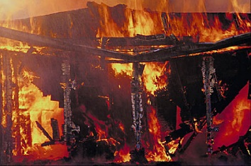
“No, it’s me, Robin. I am sure she is fine and isn’t upset. Come outside you will see. Come, let us leave this place and go outside.” Robin pleaded, hoping to appeal to whatever rational part was left in Will’s head.

After much careful coercing and reassurance that he was indeed still alive, Robin managed to get Will to stand. Gone was the obnoxious teenager who had caused Robin such misery and embarrassed his master daily. This man-child quietly whimpering, reduced to madness, was just a shadow of who he had been mere days earlier. In an instant Robin’s faint feeling of success was shadowed by a loud creaking from above and a change in the noise both of the fire and onlookers which could only signify trouble. Looking up Robin watched, open mouthed and disbelieving as the timber frames of the cathedral’s roof abruptly burst into flames, no longer able to withstand the onslaught of the heat from outside. Within seconds a mixture of beams and plaster began to fall in avalanches all around them, great hunks of stone bursting like cannons out of the disintegrating structure, threatening to trap them inside this hell on earth. No longer able to spare time gently coaxing, Robin grabbed Will and began a series of leaps, jumps and bounds towards freedom. Everywhere Robin turned flames grew higher, huge chunks of masonry and timber fell crashing from the walls and ceiling around him, trapping him and Will. Reluctantly, Robin began to loose hope. Was he to die here? At least he had been able to save some people, and yet…
Robin, already struggling for breath in the smoky, fire fueled air, began to feel himself fading. As everything around him started to become dim, and his legs began to grow weak he was startled by an even louder crash. Drawing on his last ounces of strength he turned towards the new noise and was astonished to see Evie’s long trunk squirting water towards him, creating a pathway of steam through which he and Will could escape. He once more pulled the half conscious Will through falling debris and sudden bursts of steam, which created a difficult, arduous route where they often had to go back on themselves or in various directions but meant that they could reach their final destination: his dearest animal friend and freedom!
After what felt like hours they emerged from the building only to hear shrieks proclaiming that the lead from the roof was dripping in torrents towards them. In one final burst of adrenalin fueled energy, Robin, remembering the trick he had taught Evie to grab him by her trunk and toss him on her back, managed to get Evie to grab and carry a bewildered Will as Robin leapt aside and out of danger. As they turned they saw the river of molten lead flowing down the streets as if the very cathedral were crying over the tragedy.

http://4.bp.blogspot.com/-VFWBlVU5N-M/TsWW3oLWWjI/AAAAAAAAA00/stV31xT_hlU/s1600/plague%2Bdoor.jpg
http://scaffoldingcompanies.blogspot.co.uk/
londonhistoricshops.blogspot.com leadenhall market
http://greatfireoflondon.net/images/london-1666.jpg
www.explore-stpauls.net
https://images.fineartamerica.com/images-medium-large/17th-century-fire-fighting-artwork-library-of-congress.jpg
https://qph.ec.quoracdn.net/main-qimg-82fc99b34cda34218f75b2341e4cfc5d
http://thebritish.sky.com/images/tweeting-history/great-fire-of-london/large/Fire-Day2-1500.jpg
The Great Fire of London 1666, P Robson p30
http://lostcityoflondon.co.uk/tag/royal-exchange/
For over 600 years, animals have been kept at the Tower of London for the entertainment of the court. Everything from elephants to lions, kangaroos and bears lived in the Royal Menagerie (like a zoo in the tower). Animals may have been given to the King as a gift from other royals in faraway countries, or, as people began to explore all over the world, were bought home by Englishmen as gifts to their royal family.
Puritan was the name given in the 16th century to the more extreme Protestants within the Church of England during the Protestant Reformation, where Henry 8th began the split of the church away from Roman Catholicism. Puritans wanted to `purify’ or simplify the church by removing all trace of Catholic influence.
A Tavern is similar to a modern day pub or coffee house. People met there to drink and talk.
A crypt is a stone chamber beneath the floor of a church which usually contains coffins, or religious relics.

